The Development of Android-Based Plane Figure Educational Game Using Unity 2D with Fisher Yates Shuffle Algorithm (A Case Study at Sekolah Dasar Negeri 1 Brobot)

Cinde Yuliga   
*Faculty of Engineering and Science,* *Informatics Engineering*  
Universitas Muhammadiyah Purwokertoline 4: City, Country  
[cindeyuliga@gmail.com](mailto:cindeyuliga@gmail.com)

Tito Pinandita  
*Faculty of Engineering and Science, Informatics Engineering*  
Universitas Muhammadiyah Purwokertoline 4: City, Country  
[titop@ump.ac.id](mailto:titop@ump.ac.id)

**Abstract—The development of educational games can be utilized optimally as one of the learning media. The learning activity applied in grade IV at SD Negeri 1 Brobot (Public Elementary School 1 of Brobot) still uses conventional methods, it makes students feel bored especially in plane figure material. This study aims to develop an Android-based plane figure educational game using Unity 2D with Fisher Yates Shuffle to increase students' interest and motivation in learning, especially in plane figure material. This study uses RD (Research and Development) using the ADDIE development model. The ADDIE stage includes Analysis, Design, Development, Implementation, Evaluation. In the validation test of the plane figure educational game, the researcher uses two validators, namely a validator as a media expert and another validator as a material expert. In addition, the plane figure educational game was tested for practicality with the subject of 3 students of grade IV at SD Negeri 1 Brobot, who were categorized as high ability (1 student), another one student in medium ability and the rest one is in low ability. At the implementation stage, the pretest and posttest were tested on 12 students to find out the effectiveness of educational games in increasing student learning. The results obtained in the plane figure educational game are from the media expert validation test getting a percentage of 82.8%, the material expert validation test getting a percentage of 87.5%, and the practicality test getting an average percentage of 82.5%. In the pretest and posttest tests, the average percentage is 27.5% pretest and the posttest score is 40.8 and the learning improvement gets an increase of 48.4%.**

***Keywords—educational game, fisher yates shuffle, android, plane figure, ADDIE.***

# Introduction

Nowadays, with the rapid development of technology, it is very important to apply technology-based learning for learning media. This can facilitate students in learning activities, and make learning not a boring thing, because of the existence of technology-based learning media [1]. The real form of technological development in the world of education is the development of educational games that are used for one of the learning media [2].

Educational games are games made to train student concentration and increase student motivation in learning, with an attractive game display [3].

Mathematics is one of the subjects that must be studied for all students, from the start of elementary school to the next level. It allows students to think logically, analytically, systematically, and critically [4]. Mathematics also studies a knowledge by using personal reasoning, therefore math is always considered a difficult thing to learn [5]. This shows the importance of mathematics for elementary school students.

SD Negeri 1 Brobot has started to introduce learning technology using computers. However, due to the lack of technology facilities that can be used, students have to go to SD Negeri 2 Brobot when they want to learn to use a computer. On a daily basis at SD Negeri 1 Brobot, learning still uses conventional methods in class IV.

Based on the above problems, the need for new innovations in mathematics learning media, with one of them developing educational games as a medium for learning mathematics on flat building material. Therefore, the development of an android-based flat building educational game with a platformer genre in 2D form as a learning medium. Educational games are expected to provide interest and increase student interest in learning math on flat building material. With the research title Development of Android-based Flat Buildings Educational Game Using Unity with Fisher Yates Shuffle Algorithm (State Elementary School 1 Brobot).

# Research and Method

This research uses R&D (Research and Development), which is research that produces certain products or develops existing products, and is tested for feasibility [6]. The resulting product is an android-based educational game, implemented using the Fisher Yates Shuffle algorithm for question randomization. The development model in this study is the ADDIE development model. [7] states that the ADDIE model is a development model that has five stages, namely Analysis, Design, Development, Implementation, Evaluation.

The first stage is the analysis stage. This stage aims to find data information needed in the development of educational games. After knowing the problem, then the next stage is the design stage, this stage aims to describe the game according to the needs of the game. After creating an educational game design, the next stage is development, which aims to develop the design into a game until it can be played, and will be tested for validation. The next stage is implementation, which aims to test the effectiveness of the game, by conducting pretests and posttests. The last stage is evaluation which aims to find out the shortcomings of the game from the results of the validation test and effectiveness test.

The data analysis technique in this study analyzes qualitative data and quantitative data. Qualitative data in the form of data criticism and suggestions from validator about the revision of the product developed and quantitative analysis of the values contained in the validation questionnaire, practicality questionnaire and pretest and posttest results. The results of the data obtained will be adjusted to the formula to calculate the presentation of product feasibility and practicality. The data is analyzed using a Likert scale, the results of the questionnaire collection will be adjusted to the feasibility percentage formula as follows:

1. Media Validation Rating Scale

|  |  |
| --- | --- |
| Rating Scale Score | Skor |
| Very bad | 1 |
| Not good | 2 |
| Good enough | 3 |
| Good | 4 |

analysis result score

Feasibility Presentation (%): X 100

maximum score

Pretest and posttest are conducted if the game has been tested for feasibility and practicality by validators. Pretest and posttest were tested on all fourth grade students totaling 12 children, to determine the improvement of students in learning and determine the effectiveness of the product as a learning media. Determining the presentation of student learning improvement, using the following calculation formula:

posttest score - pretest score

learning improvement: X 100

pretest score

# Results and Discussion

## Analysis stage

Analysis is carried out before designing the product to find out the problems, needs, characteristics of students and solutions in learning so that the product developed is more targeted.

1. Media Validation Criteria

|  |  |
| --- | --- |
| Identification | Needs |
| Student needs | Using conventional methods, and not yet applying digital media used for daily learning, precisely on the material of flat shapes in class IV. |
| Curriculum | Implementing an independent curriculum. In the independent curriculum, students are required to be more active in learning. |
| Student characteristics | Students will be happier in learning flat shapes with digital image media and many students are less interested in math. |
| Learning Objectives | Students are more familiar with the types of shapes of flat shapes and know how to calculate the perimeter area. |

Needs in learning media by developing android-based educational games containing flat building materials and how to calculate the area and perimeter of flat buildings.

## Design Stage

## In this study using Adobe Illustrator 2020 in making game designs or assets needed in the development of educational games. Media design is described through flowchart, interface design, usecase and storyboard.

## Use case

Use Case Diagram serves as a representation of the interaction between the system and the player so that users can understand and understand the use of the system to be created. Can be seen in the Fig. 1.

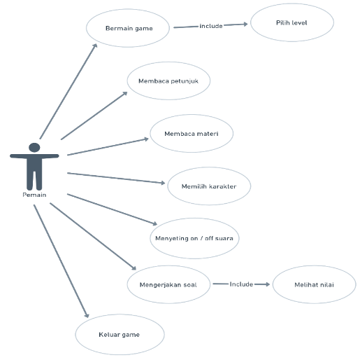

Fig. 1. Use case

Use case shows players can play games and bring up select levels so that players choose the level, read instructions, read material, choose characters, set on/off sound, do questions and players can see the final score after doing the questions, exit the game.

## Development stage

At the development stage the educational game is developed according to the game design that has been made to become a game. The development stage is carried out in several stages, namely the development of educational games, testing the fisher yates shuffle algorithm and validation tests.

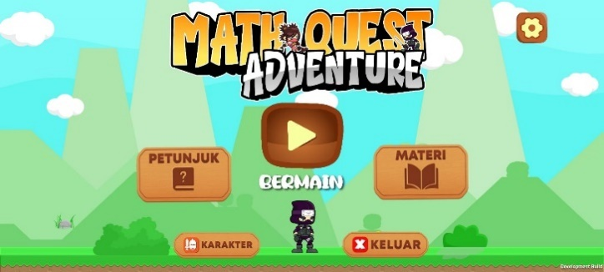 The main page is the first appearance that is seen when the player opens the game. The main page has several pages, namely, the play page, the material page, the instructions page, the settings page and the exit page. pictures can be seen in Fig. 2.

Fig. 2. Home Page

The play page has levels in the game, namely level 1, level 2, and level 3. When the player just starts the game, the level that opens is only level 1 and the other levels open if the player can win the game at each level. pictures can be seen in Fig. 3.

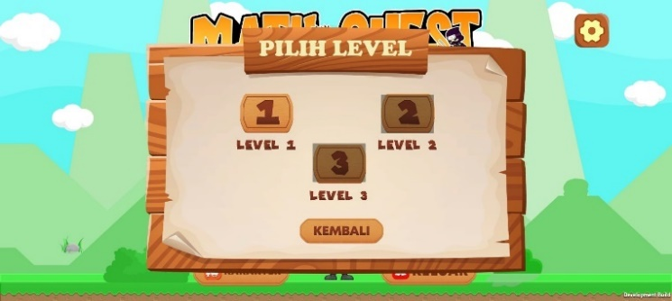Fig. 3. Level page

The material page has various choices of flat shapes and in each flat shape there is material that can be learned related to the flat shape. pictures can be seen in Fig. 4.

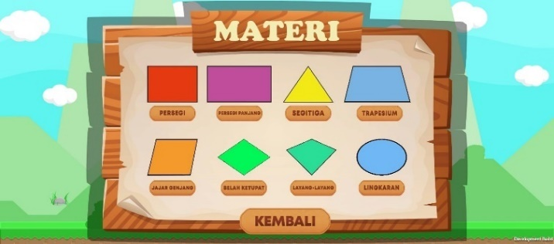Fig. 4. Material page

The character page has a choice of characters that will be played in the game. There are 2 main characters that can be played for the first time, and can buy characters when coins are sufficient. Can be seen in the Fig. 5.

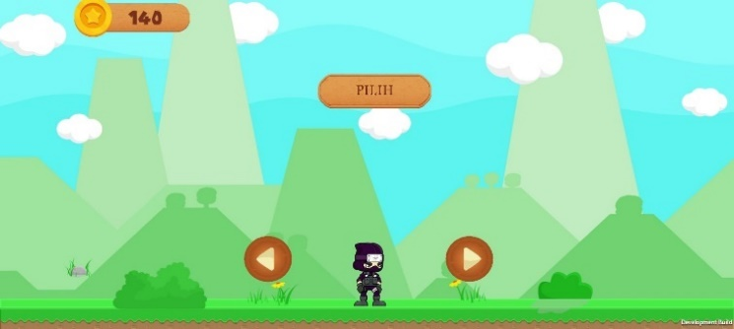Fig. 5. Character page

The gameplay display has 3 levels, namely level 1, level 2, level 3, and each level has a different background and zone. In the gameplay view, there are maps of the area with enemies, coins owned, lives, timers and navigation buttons such as buttons to the right, left, jump and shoot. pictures can be seen in Fig. 6, Fig. 7, Fig. 8.

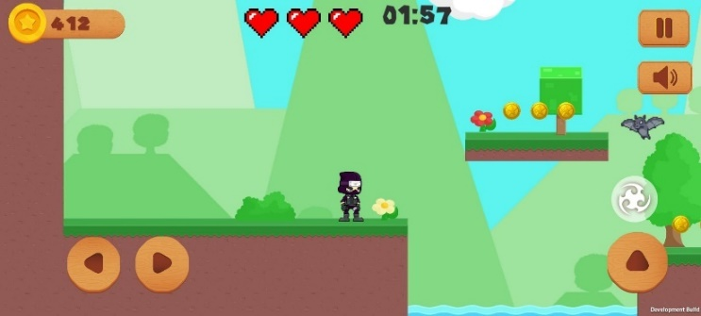Fig. 6. .Level 1 page

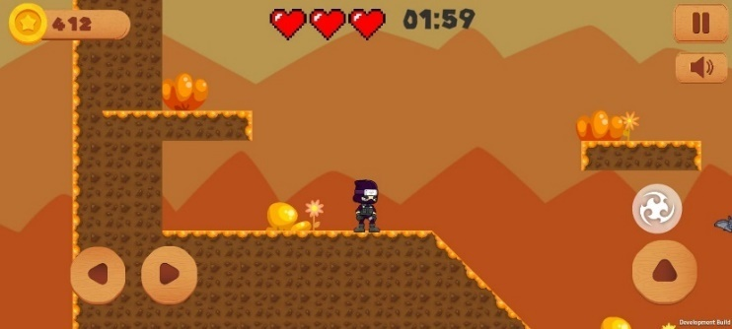Fig. 7. Level 2 page

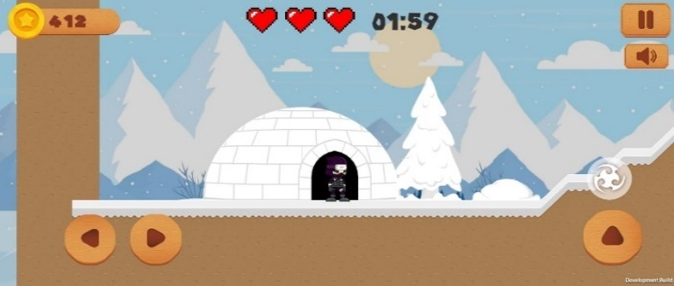Fig. 8. Level 3 page

The question page has questions and answer options with flat building material which functions for players to learn to do questions related to flat building material. On the question page there is also a processing time of 10 minutes and a description of the number of questions that come out. The question page is on each level and has a level of difficulty in the type of question and there are 50 randomized questions with 5 questions that are done while playing. Pictures can be seen in Fig. 9.

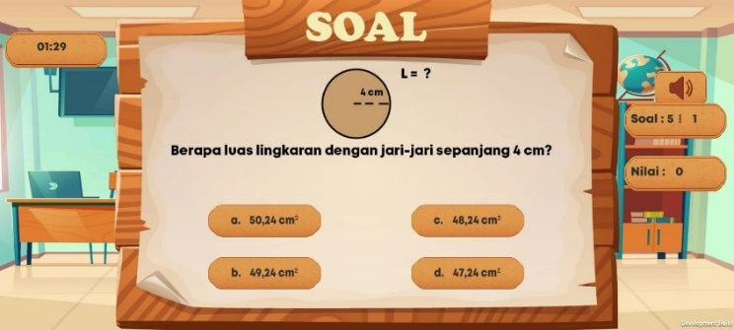Fig. *9*. Question page

The value page appears when the player finishes working on 5 questions contained on the question page at each level with the provisions of 1 correct answer worth 20 and the wrong answer worth 0. The value here is to open the next level if you get a score of 60 or more. Pictures can be seen in Pig. 10.

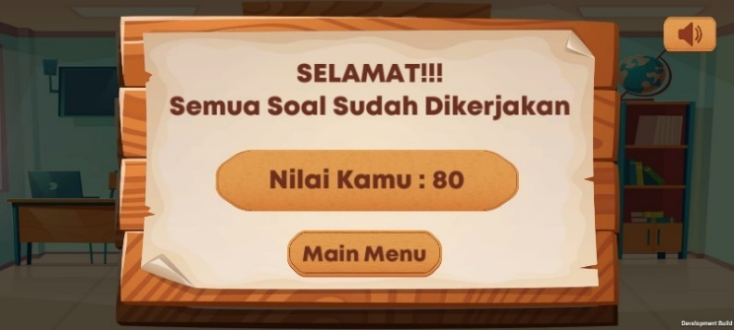Fig. 10. Result page

Product validation was carried out by 2 validators who were divided into validator 1 was a media expert and validator 2 was a material expert.

1. Media Expert Validation Results

|  |  |  |  |
| --- | --- | --- | --- |
| No | Assessment aspect | Number of items | Score acquisition |
| 1 | Interface | 11 | 45 |
| 2 | Usability | 3 | 13 |
| Total | | 14 | 58 |
| Maximum score | | | 70 |
| *Percentage of feasibility* | | | 82,8% |

Based on the results of the above calculations, the media expert validation test received a percentage of 82.8%, so that the educational game media expert validation test was included in the "Very good" category and could be used before making revisions.

1. Material Expert Validation Results

|  |  |  |  |
| --- | --- | --- | --- |
| NO | Assessment aspect | Number of items | Score acquisition |
| 1 | Material Content | 3 | 14 |
| 2 | Product eligibility | 4 | 17 |
| 3 | Language feasibility | 1 | 4 |
| Total | | 8 | 35 |
| Maximum score | | | 40 |
| Feasibility percentage 87,5% | | | |

Based on the results of the above calculations, the material expert validation test received a percentage of 87.5%, so that the material validation test fell into the "Very good" category.

1. Practicality Validation Results

|  |  |  |  |
| --- | --- | --- | --- |
| NO | Assessment aspect | Number of items | Score acquisition |
|  |  |  | High Medium Low |
| 1 | Convenience | 3 | 12 12 12 |
| 2 | Ease of play | 3 | 13 11 11 |
| 3 | Language | 2 | 10 10 8 |
| Total | | 8 | 35 33 31 |
| Maximum score | | | 40 40 40 |
| Percentage | | | 87,5% 82,5% 77,5% |
| Average percentage | | | 82,5% |

Based on the results of calculations from 3 students with high, medium and low abilities, the practicality test obtained an average percentage of 82.5%, so that the practicality test fell into the "Very Practical" category.

## Implementation Stage

After the product has been validated as suitable for use, then at the implementation stage the effectiveness of the educational game will be tested by conducting pretests and posttests to 12 fourth grade students of SD Negeri 1 Brobot. This is to determine the improvement of students' abilities before using educational games and after using educational games.

The pretest was conducted by working on multiple choice questions about flat shapes as many as 10 questions in 35 minutes. Pretest is done according to the initial ability of students before using educational games.

The posttest was carried out on the next 2 days after the pretest was carried out and students had used educational games as learning media. The posttest was carried out by working on 10 multiple choice questions that were the same as the questions given during the pretest.

1. Pretest and Posttest Results

|  |  |  |  |
| --- | --- | --- | --- |
| No | Student | Pretest score | Posttest Score |
| 1 | Student 1 | 20 | 50 |
| 2 | Student 2 | 20 | 20 |
| 3 | Student 3 | 50 | 50 |
| 4 | Student 4 | 30 | 40 |
| 5 | Student 5 | 20 | 30 |
| 6 | Student 6 | 30 | 40 |
| 7 | Student 7 | 20 | 50 |
| 8 | Student 8 | 30 | 60 |
| 9 | Student 9 | 10 | 10 |
| 10 | Student 10 | 30 | 50 |
| 11 | Student 11 | 40 | 40 |
| 12 | Student 12 | 30 | 50 |
| Total | | 330 | 490 |
| Average | | 27,5 | 40,8 |
| *Percentage increase* 48,4% | | | |

The average pretest score of 12 students was 27.5 and the average posttest score was 40.8.1 This shows that the posttest score is better than the presttest score. Calculated using the formula for the percentage of learning improvement from 12 students after using educational games as learning media, the learning improvement was 62.0%.

## Evaluation

The evaluation stage is carried out in tandem with the implementation stage. Evaluation is carried out from the results of media experts, material experts, student response results, pretest and posttest results.

# Conclusions

From the results of the research and discussion that has been compiled, the following conclusions can be drawn:

The development of an android-based flat building educational game using unity 2D with the fisher yates shuffle algorithm has been developed systematically using the ADDIE model according to Branch which consists of five stages. Educational games get a positive response from students and teachers of class IV SD Negeri 1 Brobot.

Analysis of the validation results of the development of android-based flat building educational games using unity 2D with the fisher yates shuffle algorithm shows the results of media expert validation of 82.8%, the results of media expert validation of 87.5% and practicality validation of 82.5%.

The implementation of the development of android-based flat building educational games using unity 2D with the fisher yates shuffle algorithm from the pretest and posttest tests has an average pretest value of 12 students is 27.5% and the average posttest value is 40.8%. This shows that the posttest value is better than the pretest value. Calculated using the formula for the percentage of learning improvement from 12 students after using educational games as learning media to get a learning improvement of 48.4%.

# References

[1] W. E. Jayanti and N. Fahriza, “Game E dukasi ‘ Kids Learning ’ Sebagai M edia Pembelajaran Dasar Untuk Anak Usia Dini Berbasis Android,” vol. VI, no. 1, pp. 72–80, 2018.

[2] I. Rofiqoh, D. Puspitasari, and Z. Nursaidah, “Pengembangan Game Math Space Adventure Sebagai Media Pembelajaran Pada Materi Pecahan Di Sekolah Dasar,” *Lentera Sriwij. J. Ilm. Pendidik. Mat.*, vol. 2, no. 1, pp. 41–54, 2020, doi: 10.36706/jls.v2i1.11445.

[3] A. ’Afwal Fuadi, “Pengembangan Media Pembelajaran Game Edukasi Berbasis Android Pada,” vol. 02, no. 01. pp. 101–109, 2020.

[4] S. Mulyati and H. Evendi, “Pembelajaran Matematika Melalui Media Game Quizizz Untuk Meningkatkan Hasil Belajar Matematika Smp 2 Bojonegara,” vol. 03, no. 01, pp. 64–73, 2020.

[5] T. A. Saputro, N. Ratu, P. Studi, P. Matematika, U. Kristen, and S. Wacana, “Pengembangan Media Pembelajaran Mengunakan Aplikasi Construct 2 Pada Materi Aljabar Kelas VII,” vol. 4, no. 1, pp. 10–23, 2018.

[6] Sugiyono, “Metode Penelitian Kuantitatif Kualitatif Dan R&D.” 2019.

[7] R. Branch, *Instructional Design: The ADDIE Approach*. Springer Science & Business Media, 2009, 2009. [Online]. Available: https://books.google.co.id/books/about/Instructional_Design_The_ADDIE_Approach.html?id=mHSwJPE099EC&redir_esc=y