Synergy Magic Chess Optimization for 3 Evolution with Binary Integer Programming
(Case Study Magic Chess v.255.1)

Jovian Dian Pratama
Department of Mathematics
Diponegoro University
Semarang, Indonesia
joviandp@lecturer.undip.ac.id
Ratri Wulandari
Department of Actuarial Science
Muhammadiyah Institute of Statistics and Business Technology
Semarang, Indonesia
ratri.wulandari@itesa.ac.id
Imas Wihdah Misshuari
Faculty of Civil Engineering and Planning
Trisakti University
West Jakarta, Indonesia
imasswmisshuari@gmail.com

Abstract— Mobile Legends: Bang Bang or MLBB is a game with the Multiplayer Online Battle Arena or MOBA genre, and this game genre is part of the Action Real Time Strategy. This arcade-mode game consists of brawl and magic chess. In magic chess mode, players must arrange pawns as heroes to create a strong synergy to defeat the opposing troops. In addition to synergy combos to manage playing strategies in Magic Chess, there are Line up heroes or hero ranks to get synergy with three evolutions. The integer program can be used in designing a plan for playing Magic Chess with the QM for Windows v5 Software. Binary PBB. The objective function modelling minimizes the number of heroes used; the problem is the number of hero slots and synergies that players want, as well as the limiting value of the binary variables, namely when 0 heroes are not used or 1 when the hero is used, the solution obtained is the formulation to optimize synergy with 3 Evolution. The result of this research is the determination of the hero taken from the beginning of the game to get 3 Evolutions.
Keywords— Magic chess, Integer program, Binary, Optimization, Sinergy

Introduction
Games are a form of entertainment, a diversion from fatigue caused by daily activities; the technology industry sector is developing quickly, including the game industry. Mobile Legends: Bang Bang! Having millions of players in the world, this game was created and developed by a game development company from Shanghai, China, called Moonton, with the number of downloads in June 2022 reaching more than 500 million [1].
MLBB is a game in the Multiplayer Online Battle Arena or MOBA genre, and this game genre is part of the Action Real Time Strategy, which is in great demand and is supported by choice of controls with many units brought directly to make the RTS seem full of action. The multiplayer game itself is a type of game that is played simultaneously with more than one person. Players will be in a virtual world to fight enemies, which uses the concept of strategy [2].
Mobile Legend consists of 2 choices of game modes: arcade, brawl, and magic chess. Magic Chess is like chess; in this mode, each player must arrange hero pawns to create a strong synergy to defeat opposing troops. But many still need to realize the mistakes in playing magic chess that end in defeat. According to Kelvin Alfiando ProPlayer mobile legend [3] nominee for gaming at XYZ DAY 2018, some mistakes that magic chess players are not aware of, namely not saving additional gold, wanting to win in the early game, choosing the wrong fate box, taking the hero first rather than choosing the item needed, chance percentage of heroes, bad item placement, don't know the hero combo and don't know the ability of the commander character. Magic chess also presents other excitement, one of which is by implementing Line Up; apart from synergy combos that can be used to set playing strategies in Magic Chess, there are Line up heroes or any line of heroes that can be used to become a strong combination of synergy combos. Mobile Legends provide popular lineup recommendations on magic chess, which can be used as a reference to be used as a strategy for defeating opponents, which can be seen in the table below:
- Popular Line Up in MAgic Chess
No | List of Synergies Emblem |  |  | Evolution
1 | 6 Gunners | 4 Lightborn | - | 1
2 | 6 Cadia Riverlands | 3 Northern Vale | 3 Weapon Masters | 1
3 | 6 Weapon Masters | 4 Abysses | 3 Northem Vale | 2
4 | 6 Astropowers | 4 Assassins | - | 2
5 | 6 Archers | 4 Abysses | - | 2
6 | 6 Elementalists | 2 Mages | 3 Superheroes | 1
7 | 6 Archers | 3 Guardians | 2 VENOMS | 1
8 | 6 Cadia Riverlands | 3 Weapon Masters | 2 Abysses | 1
9 | 4 Abysses | 4 Wrestlers | 3 Weapon Masters | 2
10 | 6 Mech Era | 4 Swordsman | 2 Targetmen | 2
Source: MLBB Magic Chess Game
This research aims to design an additional strategy (line up) in the Magic Chess game to get a line up with three evolutions, using a binary integer program with the help of Software QM for Windows v5.

Theoretical Review
According to [4] an optimization technique that is most effective and often used in determining problem solving that aims to maximize or minimize is known as linear programming [5], [6]. In this model there are 2 methods that can be used, namely the Graphical Method and the Simplex Method. The graphical method is a way that can be used to solve optimization problems [7] in linear programming with variables that can be used is limited (only two) whereas The simplex method is an iterative algebraic procedure that moves step by step, starting from the extreme point in the feasible region (sousi space) to the optimum extreme point. This model cannot be used in some cases. According to [8] a problem that can be said to be a linear programming problem must have special characteristics, namely that all the compilation variables are not negative and the objective function can be expressed as a linear function of the variables [9] Integer programming is a part of linear programming where all or some of the decision variables have a weaker disibility assumption. Branch and bound is one of the methods to produce optimal solutions to linear programs. This method is often used to solve an integer program problem because the results obtained in the optimal solution are more accurate and better than the other two methods. The main weakness of this method is that the procedure for achieving optimal results is very long [10]
The model of binary integer programming as follows:
Minimum right
$\sum_{j=1}^{n}{c_{j}φ_{j}}$ (1)
With constraints
$\sum_{j=1}^{n}{a_{ij}φ_{j}=b_{i},i=1,2,3,4,…,m}$ (2)
$φ_{j}=0$or 1, for some or for all j = 1, 2, 3… ,n
Binary Integer Linear Programming method in modeling problems related to resource allocation that has a decision value in the form of an integer and in it there is a linear equation that explains the utilization of the operating space. Then the process of determining the value of the decision variable as a solution to the optimal value is used by QM for Windows v5 software.

Research Methodology
The research steps in this study are described in the following steps:
- Assemble five new Line Ups with 3 Evolutions
- Modeling the problem in the form of a binary integer program
- Establishing the Objective Function minimizes the number of heroes collected
- Forming Obstacles to fulfil synergy in the lineup mentioned in number 1, as well as blessing constraints, additional synergy, and hero slots.
- Forming decision variables, namely the heroes used or collected from the start of the game.
- Incorporated optimization problem modelling into QM for Windows v5
- A solution is obtained using the help of QM Software for Windows v5
- implementation into the Magic Chess game.
Thus the following research steps from start to finish, for details will be explained in detail in the results and discussion.

Results and Discussion
The research methodology employed in this study encompasses the following steps: assembling five new Line Ups with 3 Evolutions, modelling the problem as a binary integer program, establishing an Objective Function to minimize the number of heroes collected, addressing obstacles related to synergy, blessing constraints, additional synergy, and hero slots, determining decision variables for the heroes used, incorporating optimization problem modelling into QM for Windows v5, obtaining a solution with the assistance of QM Software for Windows v5, and implementing the optimized strategies into the Magic Chess game. A comprehensive exploration of these research steps, from inception to fruition, will be presented and discussed in detail in the results and discussion chapter.
Results and Discussion will be discussed modelling integer programs for line-up recommendations other than the popular line-ups recommended by Game Magic Chess. In this paper, the author recommends several lineups, namely:
- Proposed line up with 3 evolutions
No | List of Synergies Emblem |  |  |  | Evo
1 | 6 Mech Era | 6 Gunner | 4 Swordsman | 2 Targetmen | 3
2 | 6 Archer | 6 Astro Power | 4 VENOM | 3 Guardian | 3
3 | 6 Wrestler | 6 Superhero | 4 Swordsman | - | 3
4 | 6 Abyss | 4 Assassin | 4 VENOM | - | 3
5 | 6 Mages | 6 Superhero | 4 VENOM | - | 3

Of the 5-line ups recommended by the author above, the line ups that the writer often sees are in the order of 1 to 4 during the game.

Binary Integer Program Modeling 6 Mech Era 6 Gunner 4 Swordsman 2 Target (3 Evolutions)

Objective Function

$$Min Z=φ_{1}+φ_{2}+φ_{3}+φ_{4}+φ_{5}+φ_{6}+φ_{7}+φ_{8}+φ_{9}+φ_{10}+φ_{11}+φ_{12}+φ_{13}+φ_{14}$$

Constraint

- Hero Slots
$$φ_{1}+φ_{2}+φ_{3}+φ_{4}+φ_{5}+φ_{6}+φ_{7}+φ_{8}+φ_{9}+φ_{10}+φ_{11}+φ_{12}+φ_{13}+φ_{14}≤9+h_{0}$$
- 6 Mech Era
$$φ_{1}+φ_{2}+φ_{3}+φ_{4}+φ_{5}+φ_{6}+φ_{7}=6-h_{1}$$
- 6 Gunners
$$φ_{3}+φ_{4}+φ_{8}+φ_{9}+φ_{10}+φ_{11}=6-h_{2}$$
- 4 Swordsmen
$$φ_{1}+φ_{2}+φ_{12}+φ_{13}=4-h_{3}$$
- 2 Targets
$$φ_{7}+φ_{14}=2-h_{4}$$
Binary Value Delimiter

$$φ_{i}=0 or 1, i=1,2,…,14$$
- Variables and Heros
Variable | Information | Variable | Information
$$φ_{1}$$ | Hayabusa | $$φ_{11}$$ | Roger
$$φ_{2}$$ | Saber | $$φ_{12}$$ | Lancelot
$$φ_{3}$$ | Lesley | $$φ_{13}$$ | Ling
$$φ_{4}$$ | Beatrix | $$φ_{14}$$ | Tigreal
$$φ_{5}$$ | Gatotkaca | $$h_{0}$$ | Bonus slots heroes
$$φ_{6}$$ | Gord | $$h_{1}$$ | The number of blessing era mech heroes
$$φ_{7}$$ | Johnson | $$h_{2}$$ | Number of gunner blessing heroes
$$φ_{8}$$ | Granger | $$h_{3}$$ | Number of swordsman blessing heroes
$$φ_{9}$$ | Layla | $$h_{4}$$ | target blessing heroes
$$φ_{10}$$ | Claude

Binary Integer Program Modeling 6 Archer 6 Astro Power 4 VENOM 3 Guardian (3 Evolutions)

Objective Function

$$Min Z=φ_{1}+φ_{2}+φ_{3}+φ_{4}+φ_{5}+φ_{6}+φ_{7}+φ_{8}+φ_{9}+φ_{10}+φ_{11}+φ_{12}+φ_{13}+φ_{14}+φ_{15}+φ_{16}$$

Constraint

- Hero Slots
$$φ_{1}+φ_{2}+φ_{3}+φ_{4}+φ_{5}+φ_{6}+φ_{7}+φ_{8}+φ_{9}+φ_{10}+φ_{11}+φ_{12}+φ_{13}+φ_{14}+φ_{15}+φ_{16}≤9+h_{0}$$
- 6 Archers
$$φ_{1}+φ_{2}+φ_{3}+φ_{4}+φ_{5}+φ_{6}=6-h_{1}$$
- 6 Astro Powers
$$φ_{2}+φ_{7}+φ_{8}+φ_{9}+φ_{10}+φ_{11}=6-h_{2}$$
- 4 VENOMS
$$φ_{4}+φ_{12}+φ_{13}+φ_{14}=4-h_{3}$$
- 3 Guardians
$$φ_{13}+φ_{15}+φ_{16}=3-h_{4}$$

Binary Value Delimiter
$$φ_{i}=0 or 1, i=1,2,…,16$$
- Variables and Heros
Variable | Information | Variable | Information
$$φ_{1}$$ | Mia | $$φ_{11}$$ | Karina
$$φ_{2}$$ | Irithel | $$φ_{12}$$ | Harleys
$$φ_{3}$$ | Bruno | $$φ_{13}$$ | Grock
$$φ_{4}$$ | Hanabi | $$φ_{14}$$ | Gusion
$$φ_{5}$$ | Wanwan | $$h_{0}$$ | Hero slot bonus (0=don't have, 1=have max 1)
$$φ_{6}$$ | Moscov | $$h_{1}$$ | Number of archer blessing heroes
$$φ_{7}$$ | Martis | $$h_{2}$$ | astro power blessing heroes
$$φ_{8}$$ | Lunox | $$h_{3}$$ | The number of VENOM blessing heroes
$$φ_{9}$$ | Odette | $$h_{4}$$ | The number of guardian blessing heroes
$$φ_{10}$$ | Badang

Binary Integer Program Modeling 6 Wrestler 6 Superhero 4 Swordsman 3 Mech Era (3 Evolutions)

Objective Function

$$Min Z=φ_{1}+φ_{2}+φ_{3}+φ_{4}+φ_{5}+φ_{6}+φ_{7}+φ_{8}+φ_{9}+φ_{10}+φ_{11}+φ_{12}+φ_{13}+φ_{14}+φ_{15}+φ_{16}$$

Constraint

- Hero Slots
$$φ_{1}+φ_{2}+φ_{3}+φ_{4}+φ_{5}+φ_{6}+φ_{7}+φ_{8}+φ_{9}+φ_{10}+φ_{11}+φ_{12}+φ_{13}+φ_{14}+φ_{15}+φ_{16}≤9+h_{0}$$
- 6 Wrestlers
$$φ_{1}+φ_{2}+φ_{3}+φ_{4}+φ_{5}=6-h_{1}$$
- 6 Superheroes
$$φ_{3}+φ_{6}+φ_{7}+φ_{8}+φ_{9}=6-h_{2}$$
- 4 Swordsmen
$$φ_{9}+φ_{10}+φ_{11}+φ_{12}=4-h_{3}$$
- 3 Mech Era
$$φ_{5}+φ_{11}+φ_{12}+φ_{13}+φ_{14}+φ_{15}+φ_{16}=3-h_{4}$$

Binary Value Delimiter
$$φ_{i}=0 or 1, i=1,2,…,16$$
- Variables and Heros
Variable | Information | Variable | Information
$$φ_{1}$$ | Aldous | $$φ_{11}$$ | Saber
$$φ_{2}$$ | Badang | $$φ_{12}$$ | Hayabusa
$$φ_{3}$$ | Chou | $$φ_{13}$$ | Lesley
$$φ_{4}$$ | Dyrroth | $$φ_{14}$$ | Gord
$$φ_{5}$$ | Gatotkaca | $$h_{0}$$ | Hero slot bonus (0=don't have, 1=have max 1)
$$φ_{6}$$ | Bruno | $$h_{1}$$ | Number of wrestler blessing heroes
$$φ_{7}$$ | Vale | $$h_{2}$$ | The number of superhero blessing heroes
$$φ_{8}$$ | Esmeralda | $$h_{3}$$ | swordman blessing heroes
$$φ_{9}$$ | Lancelot | $$h_{4}$$ | The number of blessing era mech heroes
$$φ_{10}$$ | Ling

Binary Integer Program Modeling 6 Abyss 4 Assassin 4 VENOM (3 Evolutions)

Objective Function
$$Min Z=φ_{1}+φ_{2}+φ_{3}+φ_{4}+φ_{5}+φ_{6}+φ_{7}+φ_{8}+φ_{9}+φ_{10}+φ_{11}$$

Constraint

- Hero Slots
$$φ_{1}+φ_{2}+φ_{3}+φ_{4}+φ_{5}+φ_{6}+φ_{7}+φ_{8}+φ_{9}+φ_{10}+φ_{11}≤9+h_{0}$$
- 6 Abysses
$$φ_{1}+φ_{2}+φ_{3}+φ_{4}+φ_{5}=6-h_{1}$$

- 4 Assassins
$$φ_{5}+φ_{6}+φ_{7}+φ_{8}=6-h_{2}$$
- 4 VENOMS
$$φ_{7}+φ_{9}+φ_{10}+φ_{11}=4-h_{3}$$

Binary Value Delimiter
$$φ_{i}=0 or 1, i=1,2,…,16$$
- Variables and Heros
Variable | Information | Variable | Information
$$φ_{1}$$ | Argus | $$φ_{9}$$ | Hanabi
$$φ_{2}$$ | Terizla | $$φ_{10}$$ | Harleys
$$φ_{3}$$ | Moscov | $$φ_{11}$$ | Grock
$$φ_{4}$$ | Dyrroth | $$h_{0}$$ | Hero slot bonus (0=don't have, 1=have max 1)
$$φ_{5}$$ | Helcurt | $$h_{1}$$ | Number of abyss blessing or synergy abyss heroes
$$φ_{6}$$ | Karina | $$h_{2}$$ | The number of assassin blessing heroes
$$φ_{7}$$ | Gusion | $$h_{3}$$ | The number of VENOM blessing heroes
$$φ_{8}$$ | Fanny

Binary Integer Program Modeling 6 Mage 6 Superhero 4 VENOM (3 Evolutions)

Objective Function

$$Min Z=φ_{1}+φ_{2}+φ_{3}+φ_{4}+φ_{5}+φ_{6}+φ_{7}+φ_{8}+φ_{9}+φ_{10}+φ_{11}+φ_{12}+φ_{13}+φ_{14}+φ_{15}+φ_{16}$$

Constraint

- Hero Slots
$$φ_{1}+φ_{2}+φ_{3}+φ_{4}+φ_{5}+φ_{6}+φ_{7}+φ_{8}+φ_{9}+φ_{10}+φ_{11}+φ_{12}+φ_{13}+φ_{14}+φ_{15}+φ_{16}≤9+h_{0}$$
- 6 Wrestlers
$$φ_{1}+φ_{2}+φ_{3}+φ_{4}+φ_{5}=6-h_{1}$$
- 6 Superheroes
$$φ_{3}+φ_{6}+φ_{7}+φ_{8}+φ_{9}=6-h_{2}$$
- 4 Swordsmen
$$φ_{9}+φ_{10}+φ_{11}+φ_{12}=4-h_{3}$$
- 3 Mech Era
$$φ_{5}+φ_{11}+φ_{12}+φ_{13}+φ_{14}+φ_{15}+φ_{16}=3-h_{4}$$

Binary Value Delimiter
$$φ_{i}=0 or 1, i=1,2,…,16$$

- Variables and Heros
Variable | Information | Variable | Information
$$φ_{1}$$ | Kadita | $$φ_{10}$$ | Chou
$$φ_{2}$$ | Odette | $$φ_{11}$$ | Lancelot
$$φ_{3}$$ | Esmeralda | $$φ_{12}$$ | Hanabi
$$φ_{4}$$ | Harleys | $$φ_{13}$$ | Grock
$$φ_{5}$$ | Chang'e | $$φ_{14}$$ | Gusion
$$φ_{6}$$ | Harith | $$h_{0}$$ | Hero slot bonus (0=don't have, 1=have max 1)
$$φ_{7}$$ | Aurora | $$h_{1}$$ | Number of heroes mage blessing
$$φ_{8}$$ | Bruno | $$h_{2}$$ | The number of superhero blessing heroes
$$φ_{9}$$ | Vale | $$h_{3}$$ | The number of VENOM blessing heroes

With $j$, a non-negative integer $h_{j}$ value will adjust to the course of the game; it can also be determined at the beginning so that the decision is clearer. The importance of $h_{j}$ will depend on the visibility of the solution. The point is that $h_{j}$ must always be prioritized to surpass other synergy or blessing heroes.

Solution Visibility
Because getting three evolutions is not easy, it is necessary to calculate the amount of synergy and additional hero slots needed to achieve three or optimal evolutions. Because of this, the following equation is made:
$$h_{0}+h_{1}+…+h_{p}=n$$

Information:
$$h_{0}=$$ | The number of additional slot hero (only one allowed)
$$p=$$ | The number of synergy constraint
$$n=$$ | The number of synergy and slot hero are needed for 3 evolution
Based on the synergy that is used for the synergy that has an effect or an evolution, this value must be limited. With the following rules:
- For maximum hero slots take 1 hero slot, then $h_{0}=0 atau 1$
- For synergy that requires 6 synergy for evolution, then $\sum{h_{i}}=0 or 1 or 2 or 3$
- For synergy that requires 4 synergy for evolution, then$\sum{h_{i}}=0 or 1 or 2$
- For synergy that requires 2 synergies to be optimal, then $\sum{h_{i}}=0 or 1$
Of course, the value depends on what is obtained during the period of the game, and solutions will develop based on changes in value.

Implementation of Simulation
Line Up recommendations for 6 Mech Era 6 Gunner 4 Swordsman 2 Target, so the visibility equation is as follows:

$$h_{0}+h_{1}+h_{2}+h_{3}+h_{4}=4$$

Value limit $h_{i},$with $i=0,1,2,3,4$. as follows:
$$h_{0}=0 or 1 \left(slot hero\right)$$
$$h_{1}=0 or 1 or 2 or 3 \left(Additional Mech Era Synergy\right)$$
$$h_{2}=0 or 1 or 2 or 3 (Additional Gunner Synergy)$$
$$h_{3}=0 or 1 or 2 (Additional Swordsman Synergy)$$
$$h_{4}=0 or 1 (Additional Targemen Synergy)$$

Because of the many solutions, the following strategy was chosen in playing:
- Trying to get 1 hero slot $\left(h_{0}=1\right)$
- Trying to get 1 additional synergy Mech Era / blessing $\left(h_{1}=1\right)$
- Trying to get 1 Gunner / blessing additional synergy $\left(h_{2}=1\right)$
- Trying to get 1 additional synergy Swordsman / blessing $\left(h_{3}=1\right)$

Therefore, modeling is obtained as follows

Objective Function

$$Min Z=φ_{1}+φ_{2}+φ_{3}+φ_{4}+φ_{5}+φ_{6}+φ_{7}+φ_{8}+φ_{9}+φ_{10}+φ_{11}+φ_{12}+φ_{13}+φ_{14}$$

Constraint

- Hero Slots
$$φ_{1}+φ_{2}+φ_{3}+φ_{4}+φ_{5}+φ_{6}+φ_{7}+φ_{8}+φ_{9}+φ_{10}+φ_{11}+φ_{12}+φ_{13}+φ_{14}≤10$$
- 6 Mech Era
$$φ_{1}+φ_{2}+φ_{3}+φ_{4}+φ_{5}+φ_{6}+φ_{7}=5$$
- 6 Gunners
$$φ_{3}+φ_{4}+φ_{8}+φ_{9}+φ_{10}+φ_{11}=5$$
- 4 Swordsmen
$$φ_{1}+φ_{2}+φ_{12}+φ_{13}=3$$
- 2 Targets
$$φ_{7}+φ_{14}=2$$

Binary Value Delimiter

$$φ_{i}=0 or 1, i=1,2,…,14$$
- Variables and Heros
Variable | Information | Variable | Information
$$φ_{1}$$ | Hayabusa | $$φ_{11}$$ | Roger
$$φ_{2}$$ | Saber | $$φ_{12}$$ | Lancelot
$$φ_{3}$$ | Lesley | $$φ_{13}$$ | Ling
$$φ_{4}$$ | Beatrix | $$φ_{14}$$ | Tigreal
$$φ_{5}$$ | Gatotkacha | $$h_{0}$$ | Hero slot bonus (0=don't have, 1=have max 1)
$$φ_{6}$$ | Gord | $$h_{1}$$ | The number of blessing era mech heroes
$$φ_{7}$$ | Johnson | $$h_{2}$$ | Number of gunner blessing heroes
$$φ_{8}$$ | Granger | $$h_{3}$$ | swordman blessing heroes
$$φ_{9}$$ | Layla | $$h_{4}$$ | target blessing heroes
$$φ_{10}$$ | Claude

Using the help of the QM for Windows v5 calculating tool, the modeling is obtained as follows:
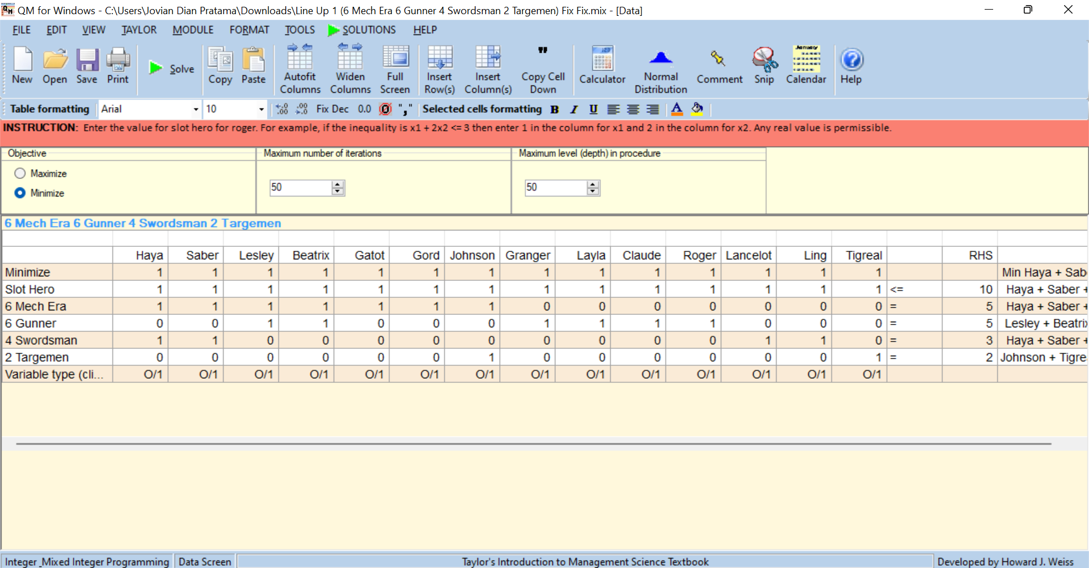
- Input QM for Windows v5 application
And obtained the following solutions:

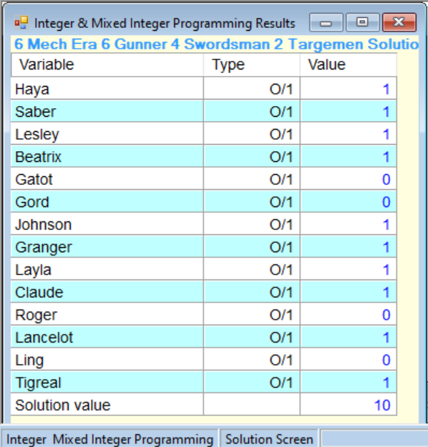
- Results for Windows v5 application
If the 4 strategy points are met, the following picture conditions will be obtained,

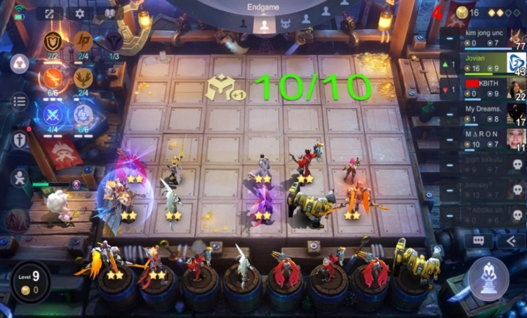
- 6 Mech Era 6 Gunner 4 Swordsman 2 Target
In Figure 3 the author gets additional hero slots ( $h_{0}=1),$Saber Blessing Mech Era $\left(h_{1}=1\right)$, Layla Blessing Gunner $\left(h_{2}=1\right)$, Hayabusa Blessing Swordsman $\left(h_{3}=1\right)$so that Evolution 3 Synergy can be fulfilled, namely Mech Era, Gunner, and Swordsman. Under these conditions Lancelot can also be replaced with Ling and Granger can be replaced with Roger, but Granger is more important because it adds 2 Synergy Lightborn.
- The modeling solution shows the results of "win"
The author doesn't claim to win 100% of the time, but one of the best strategies to get first place in Magic Chess is a strong combination of Synergy. As well as from the UN Binary modeling solution directing heroes that should have been collected from the start of the game.

Conclusion and Recommendation
Binary integer program can be applied to design strategies for playing Magic Chess. Modeling is done by designing an objective function in the form of many heroes used to form a line up with constraints in the form of many hero slots and the synergy desired by the user, the limiting value of the binary variables is 0 when the hero is not used or 1 when the hero is used. The modeling solution obtained is the user's chosen hero to optimize Synergy with 3 Evolutions and calculate how many additional heroes or synergy are needed. Binary Integer program, binary synergy optimization, can be used as a reference for lineup recommendations outside the popular recommended lineup in Mobile Legends: Bang Bang, which is only 1 to 2 evolutions.
The following research results contribute to science, especially applied mathematics and game studies, determining game strategy using binary integer programs. The form of application or implication of the binary integer program is strategic decision-making by forming a combination of heroes with three evolutions.
The following research can only be applied to Magic Chess v.255.1, where in the next version, there will be changes starting from the hero, synergy, and adding rules in the game for balance in the game and avoiding bugs. The following research is a proposed strategy that will continue to change along with updates in the following versions of magic chess.

References
[1] MLBB Game, “Mobile Legends: Bang Bang,” MLBB Web, 2022. https://m.mobilelegends.com/en
[2] D. P. Bangun and E. I. S. S. Harahap, “Fenomena Bermain Game Online Mobile Legend Terhadap Perilaku Komunikasi Antar Pribadi Mahasiswa Fakultas Ekonomi Universitas Darma Agung Medan,” J. Soc. Opin. J. Ilm. Ilmu Komunikasi; Vol 6 No 1 April, Apr. 2021.
[3] Kelvin, “Youtube Channel Kelvin Gaming,” Youtube, 2022. https://www.youtube.com/@kelvingaming7
[4] D. Stapleton, Drew M. ; Hanna, Joe B. ; Markussen, “Marketing strategy optimization : using linear programming to establish an optimal marketing mixture,” Am. Bus. Rev., vol. 21, pp. 54–62, 2003.
[5] Hamdy A. T, Operations Research. University of Arkansas, Fayetteville: Global edition, 2017.
[6] N. NARI, “Integer Programming Dengan Pendekatan Metode Branch and Bound,” J. Sainstek IAIN Batusangkar, vol. 5, no. 1, pp. 55–61, 2013, doi: 10.31958/js.v5i1.82.
[7] S. Christian, “Penerapan Linear Programming untuk Mengoptimalkan Jumlah Produksi dalam Memperoleh Keuntungan Maksimal pada CV Cipta Unggul Pratama,” The Winners, vol. 14, p. 55, Mar. 2013, doi: 10.21512/tw.v14i1.645.
[8] Jong Jek Siang, Riset Operasi dalam Pendekatan Algoritmis, 1st ed. Yogyakarta: CV. ANDI OFFSET, 2011.
[9] E. Susanti, E. S. Cahyono, and O. Dwipurwani, “Optimasi Kendaraan Pengangkut Sampah di Kecamatan Kertapati Menggunakan Pemrograman Bilangan Bulat Biner 0 dan 1,” J. Mat., vol. 6, no. 2, p. 79, 2016, doi: 10.24843/jmat.2016.v06.i02.p70.
[10] A. Rachman and A. Suparno, “Alokasi Ruang Operasi dengan Metode Binary Integer Linear Programming di Rumah Sakit Pmi Bogor,” Penelit. dan Apl. Sist. dan Tek. Ind., vol. 8, no. 1, 2014.

