Interactive Horror Story Games and Its Core Drive Implementations: Case Study on The Dark Pictures Anthology Season One Games

Galih Dea Pratama
Computer Science Department
School of Computer Science
Bina Nusantara University
Jakarta, Indonesia
galih.pratama001@binus.ac.id
Andien Dwi Novika
Master of Computer Science
Binus Graduate Program
Bina Nusantara University
Jakarta, Indonesia
andien.novika@binus.ac.id

Abstract—In presenting immersive gameplay experience to its base of players, various game titles provide certain game techniques in its disposal. As in The Dark Pictures Anthology games, the series provides branching narrative to add the layers of challenge given to the player. In order to persuade the player to complete the game, there are Core Drives which embody the player’s motivation throughout the game itself. In this research, we will present how the Core Drives are represented in interactive horror story games through the experiment on The Dark Pictures Anthology Season One games with analysis on the Core Drives using Octalysis framework. The experiment shows that the game series brought many game techniques, with Narrative, Progress Bar, Instant Feedback, alongside Plant-Poison Picker, Count Down Timer, Visual Grave, and Rightful Heritage becoming the prominent techniques from the series.
Keywords—game design analysis, Core Drive analysis, interactive story, The Dark Pictures Anthology Season One, Octalysis framework

Introduction
Video game is one of many media that has a purpose to present enjoyment among its users, especially for the segmented consumers. To fulfill the purpose, there are many game elements brought in order to complete the core gameplay. One example of the game element is called narrative, which is the embodiment of storyline given to the players. Narrative itself refers to anything related to the story that players, mostly to drive players in diving deeper to the game. There are many forms of narrative in games, such as opening sequence in introducing the story at the beginning, cut-scenes between the gameplay segments, and as an ending sequence to put a closure after the player completes the game [1].
To give immersive experience for the players, there are a lot of ways to present its narrative. To accommodate that, there comes interactive story in many game titles. It differs from normal story, where the interactive story gives liberty to the players in changing the path of storyline through their actions. Due to that, there are many variations of story in the game, giving the importance of each action and further enhancing the need to replay the game [1].
In the modern video game industry, there are many titles that implement interactive story among its narratives, such as Life is Strange series [2] and Detroit: Become Human [3] which emphasize on taking actions alongside the consequences thereafter. From the popularity of those games, The Dark Pictures Anthology [4] comes offering the player with the narrative which flows in line to the actions taken within the gameplay. Divided into season, the first season of the anthology presents the players with four games, such as Man of Medan [5], Little Hope [6], House of Ashes [7], and The Devil in Me [8], where each installment gives different main story to entertain the players. Albeit the difference in story, each title puts emphasis on the player having to endure the consequence of the actions chosen, either directly or later on.
In every game, there are certain motivations for the player to play and finish the game. These things are called Core Drive, embodying the desires that the players felt during the gameplay, from the start until the end. To get better understanding on the matter, there is Octalysis framework that breaks down the game elements of the game into eight Core Drives such as Epic Meaning & Calling, Development & Accomplishment, Empowerment of Creativity & Feedback, Ownership & Possession, Social Influence & Relatedness, Scarcity & Impatience, Unpredictability & Curiosity, and Loss & Avoidance. The framework utilization provides deep analysis on how each Core Drive is represented in game as forms to enhance the player’s motivation along the line [9].
Octalysis is actually a framework that accommodates the need to bring gamification with the emphasized analysis on the Core Drives. Nevertheless, the framework can also be implemented in analyzing the game design on certain game titles from the industry itself, such as Diablo II that became the basis of the framework’s creation. The action game brought some Core Drives, such as Epic Meaning & Calling and Empowerment of Creativity & Feedback. Epic Meaning & Calling is represented through the usage of Beginner’s Luck game element, particularly when the player finds weapons with special skill in its disposal. On the other hand, Empowerment of Creativity & Feedback is implemented via Plant Picker game element, giving the player options of skills alongside the main character’s development [10].
Octalysis itself can be used in many fields of research, particularly as audit framework for various modern technology-based application to analyze the gamification aspect of the applications. The framework usage can be found in [11] which puts Kahoot to be analyzed and in [12] which analyzed numerous healthcare applications. Both research found several techniques to accommodate gamification aspect within the applications. Despite that, none of the research utilized the framework to analyze the video game titles from various game companies.
Through the existence of Octalysis gamification framework and the lack of analysis on Core Drive implementation of video games itself, the authors wanted to analyze how Core Drives are translated into the game. This paper will show how The Dark Pictures Anthology Season One games represented the Core Drives through series of game elements. Along with that, the authors wanted that the analysis presented here can give insights on other researchers in doing the same research, either using the same framework or different ones. Furthermore, this analysis can also be useful for game developers which wanted to present game that will satisfy its intended target users.

Methodology
In this section, the coverage will be centered on the basic theory of Octalysis framework that is used in the experiment of this research along with its modern usage by other researchers. Along with that, the actions involving this research will be explained systematically, especially related to the constraints and scope contained within.

Octalysis Framework
Octalysis exists because there are some popular game titles in video game industry, and each game has its own way to urge the player to have their definition of fun. The way they act is not always same, there are some titles that bring inspiration and empowerment and there are some other that emphasize manipulation and player’s obsession. This method called Core Drive and it is the base of Octalysis which often represented as octagonal [9].
Core Drive divided into eight segments can be distinguished as the main characteristic of Octalysis framework. Core Drive itself appears as a motivation sign from the player’s side. Core Drive consists of Epic Meaning & Calling, Development & Accomplishment, Empowerment of Creativity & Feedback, Ownership & Possession, Social Influence & Relatedness, Scarcity & Impatience, Unpredictability & Curiosity, and Loss & Avoidance. Each Core Drive has its own game element shown in Figure 1 [9].
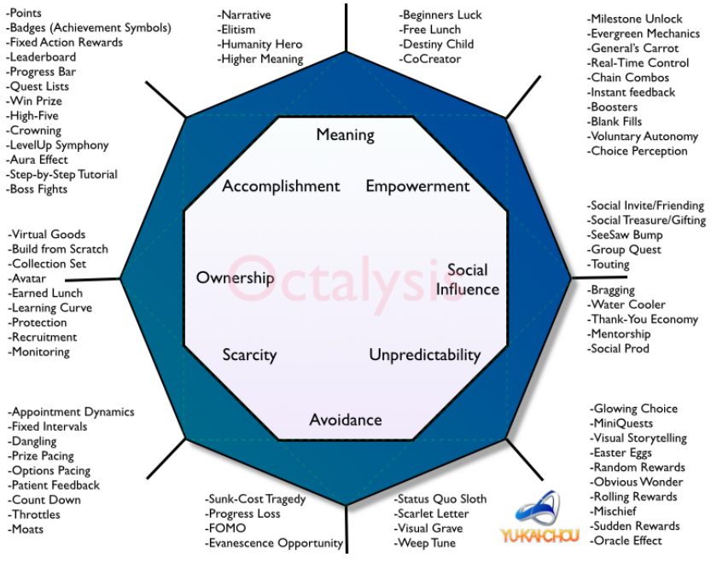
Figure 1. Octalysis Framework [9]
The first Core Drive called Epic Meaning & Calling that is shown in Figure 2. The player presented as if they are the chosen one, or they are the one supposed to do certain things and has bigger importance than their own self. There are many game techniques which can be applied to delve into this Core Drive. One of the most popular game techniques is Narrative, where it is used as a reason why the player must play the game. The other game technique that can be used is Humanity Hero, where it could give the feeling of being the sole savior to the player [9].
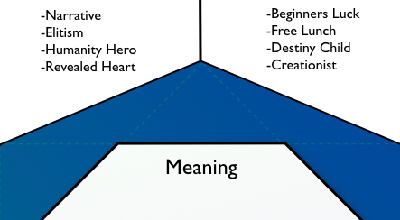
Figure 2. Epic Meaning & Calling in Octalysis Framework [9]
The second Core Drive is called Development & Accomplishment. The game techniques owned by this Core Drive are shown on Figure 3. Called as the most common Core Drive, the motivation in this Core Drive could appear due to the desire of human evolution, achieving expertise, and overcoming obstacles upfront. Progress Bar can be used to represent this Core Drive as a sign of the player evolving over time. Usage of this Core Drive can be used as evidence that player has gained many expected things in game [9].
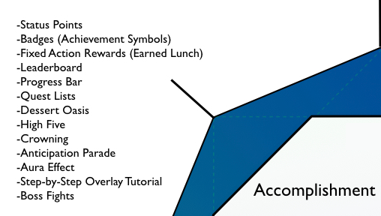
Figure 3. Development & Accomplishment in Octalysis Framework [9]
The third Core Drive is commonly known as Empowerment of Creativity & Feedback, which can be seen in Figure 4. This Core Drive focuses on how the player is motivated to grow creatively, namely by discovering new things and trying different combinations during time. Milestone Unlock is one of the game techniques that can be used to trigger this Core Drive. Milestone Unlock gives the player a chance which has never been experienced before. Plant Picker and Poison Picker are the other game techniques that could help player choose the best combination in some cases [9].
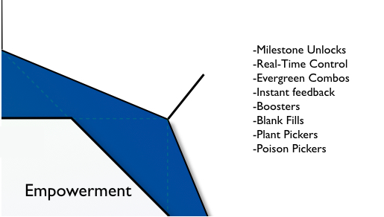
Figure 4. Empowerment of Creativity & Feedback in Octalysis Framework [9]
Ownership & Possession is the fourth Core Drive, which is shown in Figure 5. This Core Drive is triggered by the player’s motivation to take control of various things. This motivation generates the player’s desire to collect or even upgrade their belongings. Implementing Collection Sets is one of the effective ways to trigger this Core Drive because it could provide opportunity to player in getting various items in specific sets. Besides collection sets, in game exchangeable point used as medium of exchange [9].
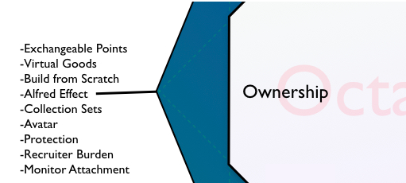
Figure 5. Ownership & Possession in Octalysis Framework [9]
The fifth Core Drive is Social Influence & Relatedness as shown on Figure 6. This Core Drive focuses on the player’s motivational trigger from social aspect like guidance, accompaniment, and competition. It appears because of the existence of the player’s interest in other people, places, or moments. One of the game techniques that could be used to highlight this Core Drive is Group Quest, where it enables the player to play with other players. There is also Social Treasure that can be used to present opportunity to share items between players [9].
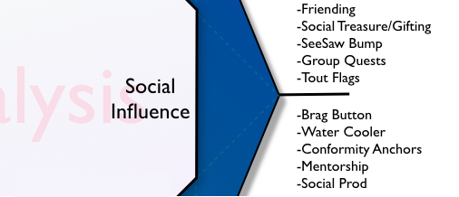
Figure 6. Social Influence & Relatedness in Octalysis Framework [9]
The sixth Core Drive is Scarcity & Impatience, shown on Figure 7. This Core Drive is seen as an intuition in possession of many things that are either rare, exclusive, or hard to get. This intuition often leads to impatience caused by the player’s inability to do certain actions immediately. Torture Breaks is a way to represent this Core Drive, where it forces the player to wait before continuing the game. Appointment dynamics in game also allow the player to only do limited actions in allotted time [9].
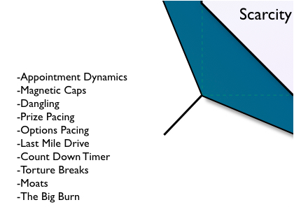
Figure 7. Scarcity & Impatience in Octalysis Framework [9]
The seventh Core Drive is called Unpredictability & Curiosity, which is shown on Figure 8. This Core Drive includes the feeling of interest that could cause curiosity. One of many ways to trigger this Core Drive is through the usage of Random Rewards. Random Rewards give unpredictable gifts, either by the amount or the form. The gifts are then given when the player finishes the game. Easter Eggs is the other way to trigger this Core Drive, which serves as element of surprise to the player. In turn, it could lead the player to play further in hopes of getting intended prize [9].
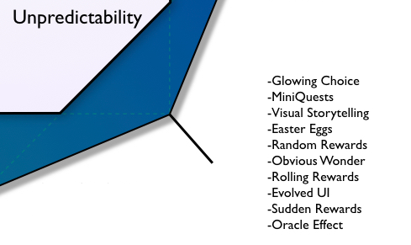
Figure 8. Unpredictability & Curiosity in Octalysis Framework [9]
The last Core Drive is called Loss & Avoidance as shown in Figure 9. This Core Drive is triggered by several things that become bad influence on the player’s side. Rightful Heritage is one way to trigger this Core Drive, where it is useful for encouraging the player to get something and producing belief that the things they wanted are their right. Beside Rightful Heritage, Progress Loss and Visual Grave are also used to induce the fear of losing when the player failed to do the asked things in the game [9].
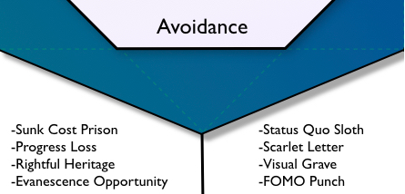
Figure 9. Loss & Avoidance in Octalysis Framework [9]
Octalysis framework is known for its use in building gamification-based system. The implementation can be seen in [13], where it focuses on the application of Android-based app for Mathematic Learning in Cangkuang 1 State Junior High School. The usage of Octalysis framework promoted the implementation of game techniques to represent each Core Drive, such as Avatar as the representation of Ownership & Possession shown in Figure 10.
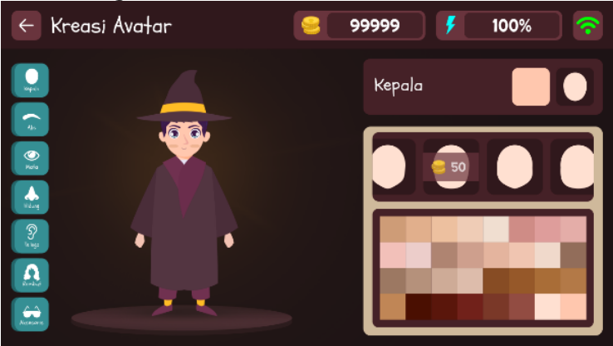
Figure 10. Avatar as Core Drive Representation [13]
Octalysis is also an audit framework, which can be used on any sorts of system or application to assess the gamification in said subjects. One example can be seen on [11] which focuses on the analysis of gamification in Kahoot. There are some game elements like Leaderboard as a Development & Accomplishment or the second core drive implementation. Kahoot’s leaderboard can be seen in Figure 11.
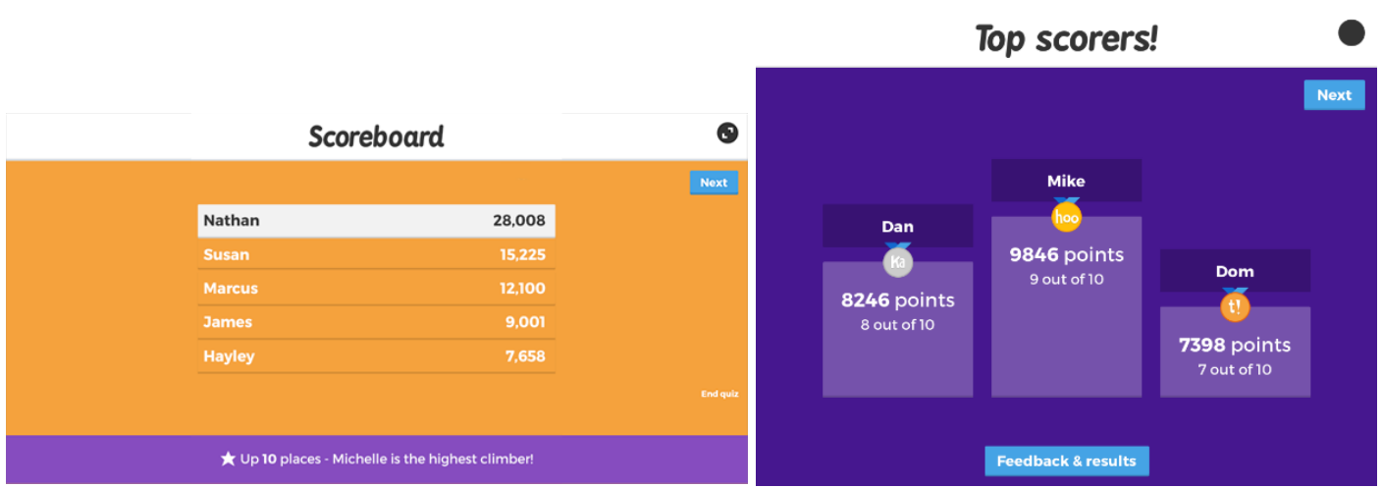
Figure 11. Representing Core Drive in Kahoot through Leaderboard [11]

Related Works
This section will present various research discussing the usage of Octalysis framework in numerous fields of study. The segment will particularly focus on the usage of framework to analyze the gamification aspect from several technology-based application in each research.
Nowadays, there are many applications which implement gamification elements within, with Kahoot as one among them and put in [11] to be analyzed using Octalysis framework. The framework is used to understand how the Core Drives are represented in the application. From the analysis, there are various techniques to accommodate the gamification aspect of Kahoot, such as the presence of question bank, scoreboard, and podium. Question bank itself represents Epic Meaning & Calling, whereas scoreboard and podium represent Development & Accomplishment.
Gamification is often presented in numerous modern digital applications to engage the users better. In [12], various healthcare applications released during earlier phase of Covid-19 global pandemic were analyzed using Octalysis framework to compare how each application presented its features. From the analysis, some of the applications used several game techniques to represent the Core Drives in Octalysis, such as power-ups and in-game rewards as the representation of Development & Accomplishment and Ownership & Possession Core Drives.
E-commerce is one of the popular applications used by people across the globe, presenting the ease of shopping through the gadgets people have. To provide better experience in online shopping, gamification is oftentimes used in various e-commerce platforms, such as Zara, H&M, TripAdvisor, Airbnb, and many others, which is analyzed in [14] with the usage of Octalysis framework. Many platforms represent the Core Drive using various techniques, such as the emergence of storytelling through personal experience of user within the community found within platforms such as Uber and BlablaCar, presenting the Epic Meaning & Calling Core Drive to provide meaning among the member within the platform’s community. Other Core Drives like Scarcity & Impatience also represented through the existence of limited offers from some platforms, which encourage the users to take the offers presented within the application. The result of gamification survey can be seen in Figure 12.

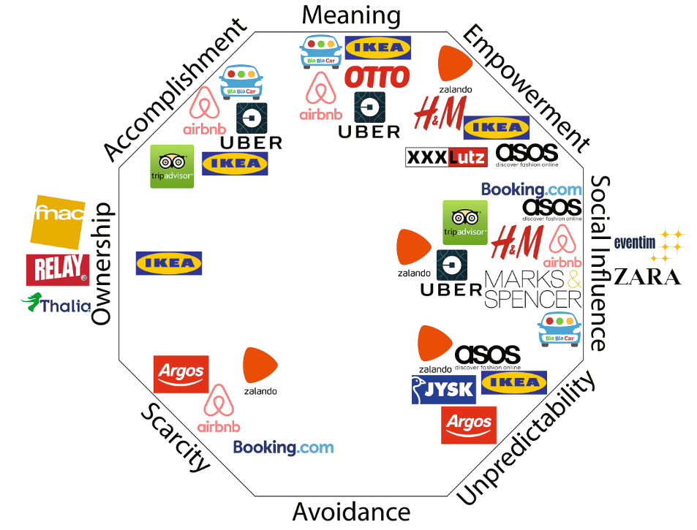
Figure 12. Result of Core Drive Mapping in Various E-Commerce Platforms [14]

Research Actions
This section will present the actions done during the process of breaking down the representation of Core Drive on The Dark Pictures Anthology Season One games. Alongside the actions, the constraints used in the experiment will be explained in order to achieve the intended results during the research.
This research experiment mainly focuses on playing The Dark Pictures Anthology Season One from the start until the end. Consists of four games, the gameplay starts from Man of Medan [5] as it is the very first title in the anthology, telling the story of group of young adults encounter a mysterious ship during their vacation. The gameplay then continues to Little Hope [6], the second title of the game series, where it tells the story of high schoolers along with their professor and academic advisor got stranded in an eerily quiet town while having to face supernatural occurrences. House of Ashes [7] comes next, which presents the story of a group of opposing armies that has to face the monster from the underground to save their lives. The Devil in Me [8] will be the last title to be played on, telling the story of investigation show crew trying to uncover the dread of legendary serial killer, eventually got trapped by the subject and have to survive at all costs.
To experience those games, this research uses a video game console platform that supports them. For that matter, we use Xbox Series S [15] to document the experimental gameplay due to its next-generation console support offered within. The Dark Pictures Anthology Season One games offer various game modes, such as pure single player and multiplayer which consists of offline and online play. Furthermore, the game series also provides Curator’s Cut, giving the chance for players to experience the story from another character’s perspective. In this research, the experiment will only be done on single player mode and the gameplay is just focused on the main story, excluding Curator’s Cut.

Results and Discussion
This section will cover the result of the experiment done to The Dark Pictures Anthology Season One games. The result will present what game features provided by the games and then continued with the Core Drive representation brought in those games. Each of the representations will also be discussed in correspondence with the analysis of this research.

Basic Game Features of The Dark Pictures Anthology Season One Games
Similar with many games published to date, The Dark Pictures Anthology Season One games provide many game features along the release. The main game features can be seen on Table 1, with the explanation of each feature will be presented in the next paragraph.
Table 1. Basic Game Features within The Dark Pictures Anthology Season One Games
Game Features | Description
Multiple split-second decisions | Supplementary of narrative, providing players with numerous choices which can alter the course of game story.
Quick-time events | One of the main features brought by the game series, with the player have to act quickly in the allotted time.
Exploration | Player can explore through traversing the provided space to collect various in-game items and progress the story further.

The Dark Pictures Anthology Season One is basically an interactive story game series, so providing multiple split-second decisions as one of the game features is pivotal in the series. This feature enhances the narrative aspect of the games, giving chance to player to shape the story in response to the options chosen during the gameplay. In the game itself, the player is presented with three choices, either act logically, emotionally, or just do nothing that can be seen. Each of the choices provides different outcome, noticeably affecting the relationship status of the other characters presented in the game and giving possibilities of twisting the plot, either directly or even later on.
To present the layer of action in The Dark Pictures Anthology Season One games, the developer uses quick-time event actions for the player. There are four main sequences of quick-time events, such as mashing a button, pressing a button (either quickly or in rhythm), and aiming at enemies. All these actions have to be completed within seconds, and the success or failure in the sections will impact the story, particularly on the fate of the playable characters.
Alongside the other two features, The Dark Pictures Anthology games also include exploration as the core feature. This feature is presented through the character traversing the given space, enabling the player to interact with the surroundings. There are many in-game items provided during the course of the games, such as old documents, temporary weapons, and many more. Those items can mostly act to elaborate the context of story in the games, giving insight on what the player has to face in the present.

The Dark Pictures Anthology Season One Core Drive Representation
This section will present how the Core Drives are represented in The Dark Pictures Anthology Season One games. The full representation is listed on Table 2, with each subsequent paragraphs will elaborate on the representation of those Core Drives.

Table 2. Core Drive Representation in The Dark Pictures Anthology Season One Games
Core Drive | Game Techniques
Epic Meaning & Calling | Narrative
Development & Accomplishment | Badges  Progress Bar  Step-by-Step Overlay Tutorial
Empowerment of Creativity & Feedback | Real-Time Control  Instant Feedback  Plant Picker  Poison Picker
Ownership & Possession | Exchangeable Points  Virtual Goods
Social Influence & Relatedness | -
Scarcity & Impatience | Count Down Timer
Unpredictability & Curiosity | Glowing Choice  Visual Storytelling
Loss & Avoidance | Visual Grave  Evanescent Opportunities  Rightful Heritage

Epic Meaning & Calling [9] is the first Core Drive that will be highlighted here. To give the player meaning and motivation to complete the game, The Dark Pictures Anthology Season One games present Narrative as the game technique. The games mainly presented five segments, with prologue that gives the background story of the settings, three main acts which focuses on the event in each game, and epilogue that provides the conclusion of the story. To provide immersive sensation in the games, the narrative can be twisted according to the decisions made by the player. The narrative changes are mostly existed in the main acts, where those changes will also affect the epilogue presented to the player.
Alongside the gameplay, Development & Accomplishment [9] is also presented in The Dark Pictures Anthology Season One games. There are many game techniques used to represent this Core Drive, such as Badges, Progress Bar, and Step-by-Step Overlay Tutorial. Badges are shown during the course of the game, mainly appearing after the player does certain actions, such as completing a quick-time event flawlessly or even keeping every playable character alive in the endgame. Progress Bar is shown through the completion of in-game items collection and the relationship of the characters. Step-by-Step Overlay Tutorial appeared only on prologue, where it provides the basic controls in the games.
Empowerment of Creativity & Feedback [9] is also represented in The Dark Pictures Anthology Season One games, which noticeably defines the core features of the game series itself. Real-Time Control enables the player to do virtually anything in the game world, such as interacting on items and choose or not choose particular decisions. Instant Feedback also appears in the games, noticeably found through in-game responses, such as the update of relationship and bearing in correspondence with the actions taken by the player. Next up, Plant Picker and Poison Picker also dominate the gameplay portion, where each actions the player does, spanning from choosing response, succeeding quick-time events, until getting in-game items provide its own merit and demerit.
Ownership & Possession [9] is a Core Drive that is not present in the first three titles of The Dark Pictures Anthology Season One games. This Core Drive made its first appearance in The Devil in Me, the latest installment in said anthology game series. This Core Drive is represented with two game techniques, such as Exchangeable Points and Virtual Goods. Exchangeable Points itself is shown through the existence of in-game items called Obol, which can be collected throughout the gameplay to be exchanged later on. To accommodate that, Virtual Goods exists to make Exchangeable Points useful. Instead of providing many kinds of unlockable items, the game only gives the player action figures of characters appeared in the game narrative.
As the experiment is focused on the single player mode of The Dark Pictures Anthology Season One games, the multiplayer mode of those games is left untouched in this research. Therefore, Social Influence & Relatedness [9] is not found during the experiment and analysis process.
Next up, Scarcity & Impatience [9] exists as another Core Drive in The Dark Pictures Anthology Season One games. This Core Drive is represented through game technique of Count Down Timer, which scattered throughout the gameplay, such as when the player has to make choice, press certain button, with those actions have to be done during the partially invisible timer. Albeit only represented with one game technique, this Core Drive also serves as the main reason why the games put the player at stake, signifying its importance in those games.
Unpredictability & Curiosity [9] also appears as Core Drive in The Dark Pictures Anthology Season One games. This Core Drive is implemented with the usage of Glowing Choice and Visual Storytelling as the game techniques. Glowing Choice can be found when the player stumbles upon glowing items during exploration segments, which sometimes leads the player to understand the game and its plot along the way. On the other hand, Visual Storytelling is presented to accommodate the narrative aspect of the games, spanning from how the characters react to the player’s chosen responses until the aftermath of the player’s actions in the gameplay.
Loss & Avoidance [9] is the last Core Drive present in The Dark Pictures Anthology Season One games. This Core Drive is represented with Visual Grave, Evanescent Opportunities, and Rightful Heritage. Visual Grave and Rightful Heritage are found through the in-game Pictures encountered during the gameplay, showing the possible events that might happen, particularly survival and demise of the playable characters. Evanescent Opportunities itself is present in correspondence with the Count Down Timer during the action sequence of the games, enabling people to miss certain chances when they fail the intended actions.

Conclusion
As narrative-heavy game series, The Dark Pictures Anthology Season One games brought Core Drives in giving the player reasons to stay occupied during the gameplay. As found during the experiment and analysis of the anthology game series, each Core Drive has its own representation, with only Social Influence & Relatedness having no game techniques due to the limitation put on this research.
For future research, this topic can be explored further with analysis on both single player and multiplayer modes, or even considering the analysis of additional contents provided in the games. This kind of research can also be implemented through the usage of different frameworks, providing broader possibilities in conducting research of various games.

References
[1] E. Adams, Fundamentals of game design, vol. 47, no. 08. 2010. doi: 10.5860/choice.47-4462.
[2] S. E. Square Enix, “Life is Strange,” Square Enix website, 2021. https://lifeisstrange.square-enix-games.com/en-us/
[3] Sony Interactive Entertainment America LLC and Quantic Dream, “Detroit : Become Human,” Quantic Dream website, 2018. https://www.quanticdream.com/en/detroit-become-human
[4] S. G. Bandai Namco, “The Dark Pictures,” The Dark Pictures website, 2022. https://www.thedarkpictures.com/
[5] B. N. Supermassive Games, “The Dark Pictures Anthology: Man of Medan,” The Dark Pictures website, 2019. https://www.thedarkpictures.com/man-of-medan
[6] B. N. Supermassive Games, “The Dark Pictures Anthology: Little Hope,” The Dark Pictures website, 2020. https://www.thedarkpictures.com/little-hope
[7] B. N. Supermassive Games, “The Dark Pictures Anthology: House of Ashes,” The Dark Pictures website, 2021. https://www.thedarkpictures.com/house-of-ashes
[8] B. N. Supermassive Games, “The Dark Pictures Anthology: The Devil in Me,” The Dark Pictures website, 2022. https://www.thedarkpictures.com/the-devil-in-me
[9] Y. Chou, Actionable Gamification: Beyond Points, Badges, and Leaderboards, 1st ed. Yu-kai Chou, 2016.
[10] Y. Chou, “Game Design Analysis of Diablo II,” Yu-kai Chou, 2016. https://yukaichou.com/gamification-study/game-design-analysis-diablo-ii-level-ii-octalysis/
[11] D. R. Ramdania, D. S. Maylawati, and M. A. Ramdhani, “Analisis Gamifikasi pada Kahoot! menggunakan Octalysis audit,” UIN Sunan Gunung Djati Digilib, vol. 1, no. 1, pp. 1–10, 2013, [Online]. Available: http://digilib.uinsgd.ac.id/id/eprint/30639
[12] B. J. Nanda, A. D. G, and P. Sharma, “Gamifying Awareness of Covid-19: A Review of the Gamified Apps Using Octalysis Framework,” Manag. Matters, vol. 18, no. 01, pp. 31–45, 2021.
[13] R. A. Syakuran and Sufa’atin, “The Application of Gamification Concept to Android-based Mathematics Learning Application in SMP Negeri 1 Cangkuang,” J. Ilm. Komput. dan Inform., 2017.
[14] J. Karać and M. Stabauer, “Gamification in e-commerce a survey based on the octalysis framework,” in HCI in Business, Government and Organizations 2017, 2017, vol. 10294, pp. 41–54. doi: 10.1007/978-3-319-58484-3_4.
[15] M. Xbox, “Xbox Series S,” Xbox Store, 2020. https://www.xbox.com/en-US/consoles/xbox-series-s

