DIGITAL MARKETING STRATEGY TO ENHANCE THE COMPETITIVENESS OF MUSLIM FASHION SMES:
A CASE STUDY OF YABUNAYA MUSLIM STORE
Cindy Rahayu^{1*}, Yunitasari Christanti², Nathanael Widjaja³
¹⁻³Computer Science Department, School of Computer Science, Bina Nusantara University,
Jakarta, Indonesia 11480
cindy.rahayu@binus.ac.id, yunitasari.christanti@binus.ac.id, Nathanael.widjaja@binus.ac.id
ABSTRACT

Tenun Ikat Troso, an indigenous weaving craft originating from Jepara, specifically Troso village, involves the intricate process of weaving fabric from warp and weft threads that are initially tied and dyed using natural pigments. The enterprising Mrs. Rahayu, who owns UMKM Yabunaya Muslim Store, embarked on her business journey in 2017. She ventured into both selling and personally manufacturing modest dresses, utilizing an assortment of Indonesian textiles, including batik prints, stamped batik (batik cap), hand-drawn batik (batik tulis), a fusion of stamped and hand-drawn batik, and handwoven fabrics created using traditional weaving tools. Mrs. Rahayu, equipped with skills acquired through private fashion courses under the guidance of industry experts at the Susan Budiharjo School (Cikini), financed her endeavors independently without any business partners. Notably, her designs remain authentically original, with no replication of other designer products. UMKM Yabunaya Muslim Store has diversified its fabric sourcing, encompassing batik fabrics from Solo, Riau, Madura, Pekalongan, Kebumen, woven fabrics from Troso, Jepara, and sasirangan fabrics from Kalimantan. The store has successfully produced approximately 60 sets of batik, Troso woven fabrics, and sasirangan dresses. Mrs. Rahayu has actively participated in exhibitions and bazaars, maintaining a strong online presence through Google My Business, while also effectively marketing her products on platforms like Instagram, Facebook, and various other social media channels.
Keywords: Technology, Business, SME Performance, Digital Marketing, Social Media, Muslim Store

INTRODUCTION
In the contemporary business landscape, the relentless pursuit of success and sustainability has instigated innovative approaches, particularly within the domain of Small and Medium-sized Enterprises (SMEs). This commitment to progress extends to the time-honoured art of Tenun Ikat Troso, a traditional weaving craft originating from Jepara, Indonesia. This intricate practice involves weaving fabric from warp and weft threads, which are meticulously tied and dyed using natural pigments. The skilled artisans behind Tenun Ikat Troso have embarked on a journey to not only augment the quantity and quality of their creations but also to diversify their marketing strategies, amplifying the sales potential of indigenous fabrics, including the esteemed Tenun Ikat Troso. This collective endeavour for enhancement, underpinned by mentorship, training, and hands-on practice, is executed in partnership with the SME collaborator, Tenun Ikat Troso Jepara SMEs.
The overarching objectives of this venture are twofold: to equip these artisans with the essential tools, such as sewing machines, necessary for efficient product manufacturing and to introduce novel marketing channels through online marketing strategies, harnessing the power of websites and social media platforms. In an age where technology and the Internet have permeated every facet of our lives, these strategies have emerged as lifelines, not only for large conglomerates but also for SMEs. Technology has evolved into an indispensable facet of the modern business toolkit, with its transformative potential becoming increasingly apparent. This paradigm shift underscores the pivotal roles of technology and the Internet in enabling success, no longer confined to corporate giants but also accessible to SMEs.
As technology and the Internet continue to reshape the business landscape, this paper undertakes an exploration of five indispensable technological solutions tailored to meet the unique needs of SMEs, positioning them as pivotal catalysts for growth and triumph. These solutions encompass a diverse array of technological innovations and applications, each contributing to the overall efficiency and competitiveness of SMEs. The solutions in question encompass tablet computers, business intelligence applications, and tools for social media marketing—each of them possesses the potential to empower SMEs, augment their decision-making acumen, and unlock fresh avenues for revenue generation. Furthermore, this paper delves into the evolution of social media, transcending its erstwhile role as a pastime to emerge as a potent marketing instrument, underscoring its escalating significance in shaping the triumph of SMEs in the digital era.

In the ensuing sections, we will embark on a comprehensive exploration of each of these technological solutions, illuminating their advantages and potential ramifications for SMEs as they navigate the terrain of growth and sustainable prosperity. By harnessing the transformative potential of technology, particularly within the context of traditional crafts like Tenun Ikat Troso, SMEs can adapt, thrive, and carve a steadfast path towards enduring success in an ever-evolving business landscape.

method
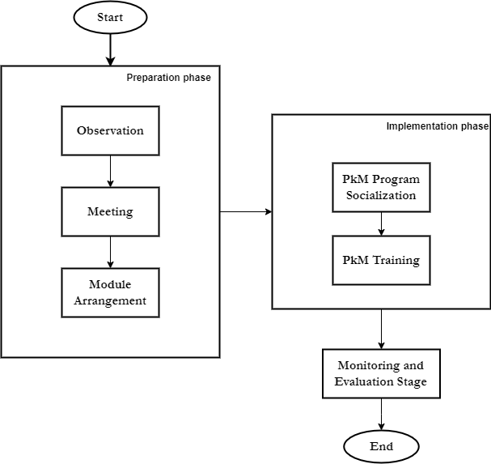
The process of enhancing the technology driven Yabunaya Muslim Store business via Digital Marketing training encompasses various stages, each characterized by its unique methodologies. A graphical depiction of the methodology employed in this research is presented in Figure 1. 1. Then, the details of proposed methods can be seen in Figure 2.

Figure 1. Research Method
The primary phase is the Preparation phase, which is subdivided into three components: observation, meetings, and module development. Observations are conducted to identify the implementation stages and goals of. Meetings serve as coordination sessions with partners to discuss scheduling, implementation timelines, and content delivery. The training preparation phase is designed to enhance focus and the smooth execution of activities. Additionally, module preparation aims to create materials that the resource person will present, whether in theory or practice, to effectively organize the event. Furthermore, at this stage, the preparation of training and seminar facilities and infrastructure is also undertaken.

The second stage is the Implementation stage, which consists of two segments: the socialization of the PkM program and the training phase. Both stages aim to introduce the program to partners who manage facilities and infrastructure. This is done to provide a detailed explanation of the objectives, benefits, contributions, and a brief overview of the training material to be delivered. The training is conducted through hands-on field practices. Regular training sessions are crucial to ensure that Yabunaya Muslim Store consistently gains new insights and maintains an interest in independently mastering business and technology.
Finally, the last stage involves Monitoring and Evaluation. Activity monitoring occurs during training, while evaluation activities take place after the training concludes. This monitoring and evaluation process is carried out on Yabunaya Muslim Store members by assessing participant responses at each stage of the PkM activities conducted by the resource persons.
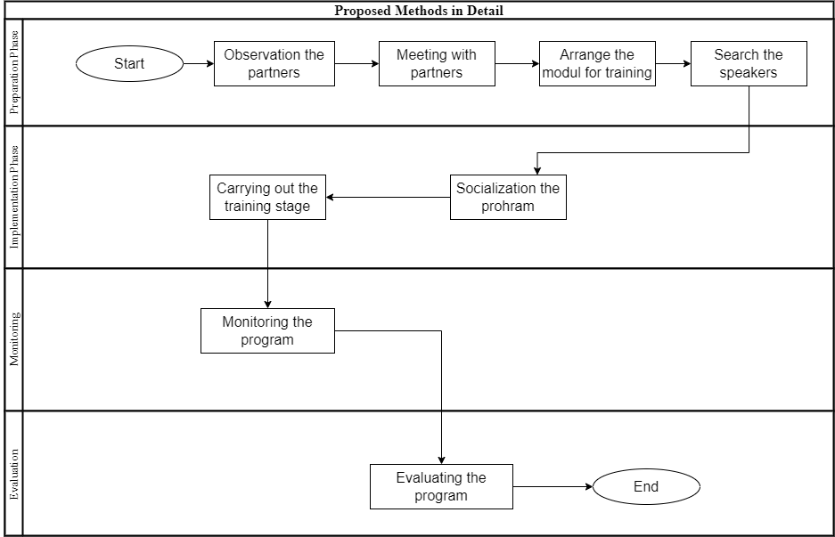

Figure 2. Proposed Methods in Detail

RESULTS AND DISCUSSION
Based on the issues identified and the observations conducted by the researchers, the research outcomes manifest in the shape of digital marketing training designed specifically for Yabunaya Muslim Store. The training is conducted by expert trainers and encompasses content creation, experimentation with various formats, caption selection, and other elements pertinent to digital marketing via social media. The lecture and discussion materials included in the training are outlined below. The ensuing section presents a breakdown of the research findings in greater detail:
Sector | Field | Details
Digital Marketing | Technology, Business | - Training sessions aimed at enhancing digital marketing skills
 |  | - Focus on assisting in the marketing of products for UMKM Yabunaya Muslim Store
Online Marketing | Technology, Business | - Building the foundational Online Shop to establish a strong online presence
 |  | - Creating various online marketing channels to support sales
 |  | - Assistance from the service team in setting up the online shop
Business Management | Business | - Conducting seminars and training sessions for business management
 |  | - Seminar and training sessions provided by the service team
 |  | - Knowledge transfer to partners for direct customer marketing
 |  | - Empowering partners to manage their business effectively
Table 1. Research Results

Due to various challenges such as limited business expansion, operating mainly on a local scale, a need for greater insight into scaling up operations, and a somewhat traditional approach with limited utilization of social media and technology, the research findings have unveiled several significant aspects. These findings include a heightened understanding of Digital Marketing, enhanced team management capabilities, the initiation of social media account creation (Instagram, TikTok Shop, Shopee, and others), and the establishment of a website domain that aligns with the technology and business sectors.
Considering these challenges, which encompass restricted business growth, a predominant local presence, limited knowledge about scaling up, and a relatively conventional approach with minimal integration of social media and technology, the research outcomes have revealed several noteworthy insights. These revelations encompass an augmented comprehension of Digital Marketing, improved team management proficiencies, the commencement of social media account creation (Instagram, TikTok Shop, Shopee, and others), and the establishment of a website domain with a focus on the technology and business sectors.

CONCLUSION
In summary, the steps taken in this endeavor have played a pivotal role in advancing the capabilities and opportunities of UMKM Yabunaya Muslim Store. The initial phase involving the acquisition of sewing machines significantly contributed to streamlining production processes, thus facilitating product manufacturing. Subsequently, the strategic development of an Online Marketing infrastructure emerged as a crucial milestone. The dedicated team meticulously established a robust online store, effectively laying the groundwork for the store's virtual presence. This comprehensive approach encompassed the creation of a dedicated website, serving as the official online platform for the store. The team also conducted training sessions and provided guidebooks, enabling knowledge transfer that empowered partners to directly engage with end-users in marketing their products.
Vital activities executed by the team included the establishment of the Online Shop foundation, utilizing the website as the primary virtual storefront. This website not only functioned as the primary online sales channel but also as a central reference point for promotional endeavors across various online channels, including social media platforms, forums, marketplaces, and other e-commerce platforms. Owning a website proved instrumental in signaling partners' commitment to their online businesses, instilling confidence in potential customers, ultimately optimizing business leverage and promotional effectiveness.
Furthermore, Social Media Marketing assumed a pivotal role. Once the primary online store was operational and populated with offered products, the team transitioned to attracting potential buyers. This involved training and mentoring partners on effectively engaging with social media platforms where a significant audience congregates. Social media platforms were harnessed as potent marketing and communication tools, acting as avenues to connect with customers. Importantly, these platforms complemented the primary website, acting as precursors to lead potential customers to the central virtual storefront.
The initiatives undertaken by the service team hold considerable potential for elevating the quality and productivity of the partners, thereby fostering an improved standard of living for UMKM Yabunaya Muslim Store, the community, and the wider society involved in the traditional art of Tenun Ikat. Partners are encouraged to harness the outcomes of these initiatives effectively, enhancing product competitiveness, human resources, and business management to bolster the overall well-being of UMKM. This collaborative effort aims to alleviate the myriad challenges typically associated with small business management, contributing to the sustained growth of UMKMs and addressing their management-related issues.

REFERENCES
Arif Pratama Marpaung. (2021). Strategi Peningkatan Kapasitas Usaha Pada Umkm Melalui Digital Marketing. Prosiding Seminar Kewirausahaan, 2(1), 294–300. Retrieved from https://www.researchgate.net/profile/Arif-Marpaung/publication/358604729_Strategi_Peningkatan_Kapasitas_Usaha_Pada_Umkm_Melalui_Digital_Marketing/links/620b328287866404a16b223f/Strategi-Peningkatan-Kapasitas-Usaha-Pada-Umkm-Melalui-Digital-Marketing.pdf
Bangun, C. S., & Purnama, S. (2022). Optimalisasi Pemanfaatan Digital Marketing untuk UMKM (Usaha Mikro, Kecil dan Menengah). ADI Pengabdian Kepada Masyarakat, 3(2), 89–98. https://doi.org/10.34306/adimas.v3i2.826
Chusniyah, I., & Fauza, N. (2022). Pelatihan Digital Marketing Bagi Pelaku UMKM sebagai Upaya Peningkatan Pemasaran di Masa Pandemi Bagi Masyarakat. Khidmatuna : Jurnal Pengabdian Masyarakat, 2(2), 138–149. https://doi.org/10.54471/khidmatuna.v2i2.1582
Faizal, I., Nanda, I., Ariestiandy, D., & Ernawati, T. (2021). Pengembangan Sistem Informasi Pengelolaan Keuangan Bagi Usaha Mikro Kecil dan Menengah (UMKM). Jurnal Sistem Komputer Dan Informatika (JSON), 3(2), 81. https://doi.org/10.30865/json.v3i2.3590
Frans Sudirjo, Arief Yanto Rukmana, Hilarius Wandan, & Muhammad Lukman Hakim. (2023). Pengaruh Kapabilitas Pemasaran, Digital Marketing Dalam Meningkatkan Kinerja Pemasaran UMKM Di Jawa Barat. Jurnal Bisnisman : Riset Bisnis Dan Manajemen, 5(1), 55–69. https://doi.org/10.52005/bisnisman.v5i1.134
Harahap, H. S., Dewi, N. K., & Ningrum, E. P. (2021). Pemanfaatan Digital Marketing Bagi UMKM. Jurnal Loyalitas Sosial: Journal of Community Service in Humanities and Social Sciences, 3(2), 77. https://doi.org/10.32493/jls.v3i2.p77-85
Harto, D., Pratiwi, S. R., Utomo, M. N., & Rahmawati, M. (2019). Penerapan Internet Marketing Dalam Meningkatkan Pendapatan Pada UMKM. JPPM (Jurnal Pengabdian Dan Pemberdayaan Masyarakat), 3(1), 39. https://doi.org/10.30595/jppm.v3i1.3033
Irfan, F. M., Suharto, & Hanif. (2023). Pengaruh Modal Usaha dan Product Innovation Terhadap Eksistensi UMKM dengan Digital Marketing Sebagai Variabel Moderating dalam Perspektif Ekonomi Islam. Jurnal Ilmiah Ekonomi Islam, 9(01), 1259–1278. Retrieved from http://dx.doi.org/10.29040/jiei.v9i1.8507
Kamil, I., Ady Bakri, A., Salingkat, S., & Pabisangan Tahirs, J. (2022). Pendampingan UMKM melalui Pemanfaatan Digital Marketing pada Platform E-Commerce. Amalee: Indonesian Journal of Community Research and Engagement, 3(2), 517–526. Retrieved from https://doi.org/10.37680/amalee.v3i2.2782
Krisnawati, D. (2018). Peran Perkembangan Teknologi Digital Pada Strategi Pemasaran Dan Jalur Distribusi Umkm Di Indonesia. Jurnal Manajemen Bisnis Krisnadwipayana, 6(1). https://doi.org/10.35137/jmbk.v6i1.175
Lina, L. F., & Permatasari, B. (2020). Social media capabilities dalam adopsi media sosial guna meningkatkan kinerja UMKM. Jembatan: Jurnal Ilmiah Manajemen, 17(2), 227-238. Retrieved from https://www.researchgate.net/profile/Lia-Lina/publication/345351471_Social_Media_Capabilities_dalam_Adopsi_Media_Sosial_Guna_Meningkatkan_Kinerja_UMKM/links/5fa4bcf8a6fdcc0624188949/Social-Media-Capabilities-dalam-Adopsi-Media-Sosial-Guna-Meningkatkan-Kinerja-UMKM.pdf
Lorensa, E., & Hidayah, N. (2022). Pengaruh inovasi produk, orientasi pasar dan media sosial terhadap kinerja umkm fashion. Jurnal Manajerial Dan Kewirausahaan, 4(3), 739-748. Retrieved from https://journal.untar.ac.id/index.php/JMDK/article/view/19768
Riyanto, S., Azis, M. N. L., & Putera, A. R. (2022). Pendampingan UMKM dalam Penggunaan Digital Marketing pada Komunitas UMKM di Kabupaten Madiun. Jurnal Abdimas BSI: Jurnal Pengabdian Kepada Masyarakat, 5(1), 137–142. https://doi.org/10.31294/jabdimas.v5i1.11534
Robby Aditya, & R Yuniardi Rusdianto. (2023). Penerapan Digital Marketing Sebagai Strategi Pemasaran UMKM. Jurnal Pelayanan Dan Pengabdian Masyarakat Indonesia, 2(2), 96–102. https://doi.org/10.55606/jppmi.v2i2.386
Sony Hendra Permana. (2017). STRATEGI PENINGKATAN USAHA MIKRO, KECIL, DAN MENENGAH (UMKM) DI INDONESIA. Strategi Peningkatan Usaha Mikro, Kecil, Dan Menengah (Umkm) Di Indonesia, 1–11. Retrieved from http://news.detik.com/
Susanti, E. (2020). Pelatihan Digital Marketing Dalam Upaya Pengembangan Usaha Berbasis Teknologi Pada Umkm Di Desa Sayang Kecamatan Jatinangor. Sawala : Jurnal Pengabdian Masyarakat Pembangunan Sosial, Desa Dan Masyarakat, 1(2), 36. https://doi.org/10.24198/sawala.v1i2.26588

