**Digital Readiness Assesment to Improve Quality of Life Using SWOT Analysis: Case Study for Natuna Regency Area**

**Irma Rizkia1\***

1 Computer Science Department, School of Computer Science,

Bina Nusantara University,

Jakarta, Indonesia 11480

irma.rizkia@binus.ac.id

*Correspondence: irma.rizkia@binus.ac.id

***Abstract –*** *Natuna Regency, as an outlying region, faces challenges in enhancing its digital readiness to effectively implement digital transformation. Currently, the digital readiness of the region remains at the survival level. This research aims to explore the most effective strategies in improving the digital readiness of the city government, and its impacts on public services and community participation. An empirical approach is employed through a case study in Natuna Regency. The research begins with a literature review and a pilot case study on the digital readiness of a region, validated through questionnaires based on the Garuda Digital Transformation Framework (GDTF) developed by ITB as the basis for measuring digital readiness in Natuna Regency. SWOT analysis is utilized to provide strategies for Natuna Regency. The digital transformation readiness of Natuna Regency is at the survival level, with a score of 60.37. Tangible impacts of digital transformation are evident in the business processes conducted by government agencies and the ecosystem of governance and society in Natuna Regency. The primary recommendation is to leverage internal strengths to address external challenges and capitalize on opportunities in the digital transformation era. Strategies include leveraging high digital literacy, understanding data security, developing technological infrastructure, enhancing human resource skills, and collaborating with the private sector and educational institutions. By integrating these strategies, Natuna Regency can more effectively respond to technological challenges and leverage digital transformation opportunities for sustainable progress.*

*Keywords: Digital Readiness, GDTF, SWOT Analysis*

1. INTRODUCTION

Digital transformation is key to enhancing efficiency, effectiveness, and connectivity in the delivery of public services by city governments(Wang & Si, 2024). By leveraging digital technology, city governments can streamline administrative processes, improve transparency, and provide more responsive services to residents.

Although digital transformation offers various benefits, city governments also face several challenges. Some of these include a lack of budget for investing in digital infrastructure, which not only impedes the progress of digital transformation but also increases the risk of digital divide between advanced and lagging regions. Additionally, uncertainties regarding data security and privacy, as well as a lack of digital literacy among government employees and the public, can be detrimental to data integrity and disrupt public services relying on such data.

*Copyright © 2025*

Digital readiness is crucial as it enables the ability to address challenges and capitalize on opportunities arising from technological changes (Ben Ghrbeia & Alzubi, 2024). City governments with high digital readiness are better able to provide quality services, enhance public participation, and foster a conducive business environment.

Previous studies have highlighted the vital role of digital readiness in shaping societal well-being. For instance, emphasizes the positive correlation between digital literacy and socio-economic development, underscoring the importance of equipping individuals with necessary digital skills (Ramdhan, 2023). Similarly, explores the impact of digital infrastructure in improving access to essential services and driving economic opportunities in remote areas (Puspita, 2024). These studies underscore the relevance of assessing digital readiness in addressing disparities and promoting inclusive development. In addition, several studies related to digital readiness were also carried out, such as creating a comprehensive assessment model that corresponds to the level of digital readiness of small and medium enterprises (SMEs) (Pirola et al., 2020), the proposed model specifically focuses on SMEs considering its modularity and convenience, understanding and conformity with the organizational structure of SMEs, building a maturity assessment method to measure the digital readiness of manufacturing companies, assessing the digital readiness index for the development of smart ports (Philipp, 2020), how a community engagement perspective involving various stakeholders can help achieve a technologically resilient city by supporting sustainable development and ultimately creating a socially inclusive urban space (Anthony, 2023). Meanwhile, there has been no research that measures digital readiness in a district based on the Garuda digital transformation framework, where these domains will be the basis for measurement in producing strategic recommendations to increase digital readiness in Natuna district to improve the quality of life in the district.

Enhancing digital readiness is necessary for city or municipal governments to keep pace with technological advancements and utilize them to maximize efficiency and effectiveness in public service delivery (Latupeirissa et al., 2024). It also aids in reducing the digital divide between advanced and lagging regions.

Recommendations for improving digital readiness include investing in technology infrastructure, training and developing digital skills for government employees and the public, developing policies supporting technological innovation, and strengthening cooperation between the public, private, and civil society sectors.

SWOT analysis can be utilized to identify the strengths, weaknesses, opportunities, and threats affecting the digital readiness of a city government. By understanding these factors, city governments can design appropriate strategies to enhance their digital readiness, including infrastructure development, training, and innovation-supporting policies.(Karmaker et al., 2023)

Considering the challenges faced by city governments in adopting digital transformation, this research aims to explore the most effective strategies in enhancing the digital readiness of city or municipal governments and their impact on public services and community participation.

II. METHODS

This research employs primary data to enhance the digital readiness of the Natuna region. It commenced with a literature review conducted simultaneously with surveys of the community and government agencies, identifying and formulating the issue, followed by establishing research objectives.

Data collection comprised two main components: a survey of 100 Natuna community respondents and government agencies (OPD) through the distribution of questionnaires and interviews. This comprehensive approach ensures a holistic perspective of the field's facts. The questionnaire data underwent validity and reliability testing. It focused on assessing digital readiness across domains such as human resources, processes, technology, data, and digital literacy, following the Garuda Digital Transformation Framework (GDTF) developed by ITB. Following the assessment of digital readiness, the next step involved analysis based on collected data from observations and questionnaires. Processed questionnaire and measurement data formed the basis for conducting a SWOT analysis. Ultimately, this research concludes by providing recommendations based on impact analysis, aiming for continuous improvement.

Once implemented, government organizations can compare their performance to desired future conditions and identify gaps or areas that need further improvement. This enables a systematic and continuous process review to maintain and enhance the digital readiness of the Natuna region. This valuable contribution allows for the development of targeted strategies to improve overall government organizational performance.

III. RESULTS AND DISCUSSION

The measurement process is conducted using Phase 1 of the GDTF (Garuda Digital Transformation Framework). Phase 1 entails measuring digital readiness through the assessment of 4 main domains and an additional domain related to Digital Literacy. Each domain consists of several parameters and indicators that serve as questions. The parameters of each domain that will become the indicators of questionnaire questions are outlined in Table 1.

Top of Form

Table 1 Domain Indicators Questionnaire

| No. | Domain | Parameter |
| --- | --- | --- |
| 1. | People | Understanding Digital Transformation |
| Cultural Transformation |
| Basic Competencies and Knowledge |
| 2. | Process | Vision and Strategy |
|  |  | Leadership |
| IT Process Maturity |
| Automation Digital Conditions |
| 3. | Technology | IT Platform Readiness |
|  |  | New Technology Readiness |
| 4. | Data | Data Management Policy |
| Data Management Unit  (non-IT) |
| Management Practice  Data |
| Internal Data Analysis |
| Social Media Data Analysis |
| Data Monetization |
| Security  Data/Information |

The results from the questionnaire responses serve as the basis for measuring digital readiness. The measurement results of digital readiness components will be mapped into several readiness levels, as illustrated in Figure 1. From the mapping results, the level of digital transformation readiness for the Natuna region will be discerned.

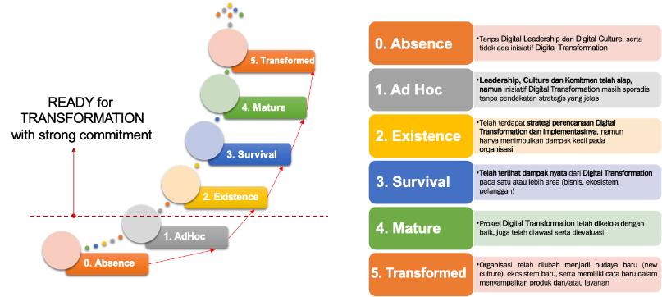

Figure 1 Quantification of Measurements in the Garuda Transformation Digital Framework

The measurement results are divided into several levels of digital readiness, as outlined in Table 2.

Table 2 Student Distribution Frequency

|  |  |
| --- | --- |
| Quantification | Explanation |
| Absence: <20% | Without digital leadership and digital culture, there is no digital transformation initiative |
| Ad Hoc: >20% - 40% | Leadership, culture and commitment are ready, but digital transformation initiatives are still sporadic without a clear strategic approach |
| Existance: >40 % - 60 % | There has been a digital transformation planning strategy and its implementation, but it has only had a small impact on the organization |
| Survival : >60% - 75% | The real impact of digital transformation has been seen in one or more areas (business, ecosystem, customers) |
| Mature: >75% - 90% | The digital transformation process has been well managed, monitored and evaluated |
| Transformed: > 90%-100% | The organization has been transformed into a new culture, a new ecosystem, and has a way of delivering products and/or services |

The results of the digital readiness measurement in the Natuna region based on the survey findings indicate that there is still a need for improvement in the Human Resources, Processes, Technology, and Data Management domains to implement digital transformation effectively in Natuna Regency. The measurement results can be seen in Figure 2. The Digital Literacy domain in Natuna Regency has the highest average value at 75.39%, followed by Data Management with an average value of 54.42%, Human Resources at 51.83%, Processes at 49.44%, and Technology at 49.09%. Overall, the total average score for digital transformation readiness in Natuna Regency is 60.37%.

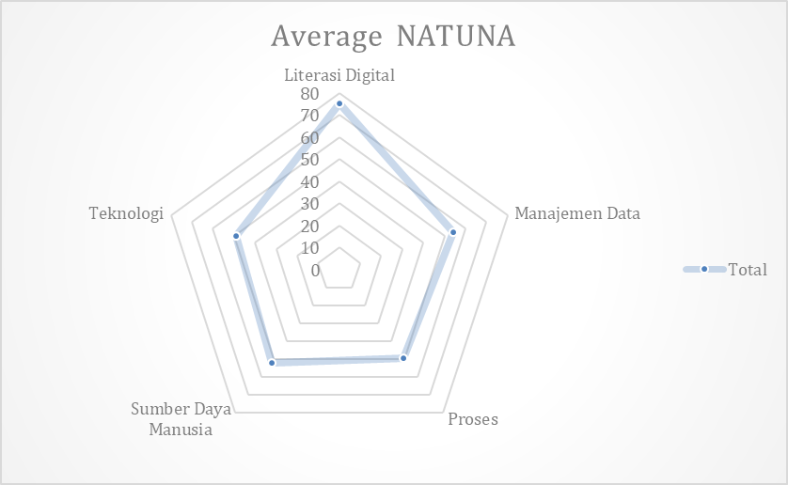Figure 2 Natuna Regency Digital Transformation Readiness

Based on the above data analysis, it can be concluded that the digital transformation readiness score of Natuna Regency falls within the Survival maturity level, where the threshold for this level is >60% - 75%. This indicates that overall, the digital transformation process in Natuna Regency has shown tangible impacts on one or more of the business processes conducted by government agencies and the ecosystem of governance and society in Natuna Regency. Generally, the local government of Natuna Regency possesses a relatively high level of digital literacy readiness for digital transformation. This is supported by the governance conducted by the government in data management processes related to the business processes of Natuna Regency's government. Additionally, there is adequate support from the existing human resources competencies within the government. The management process of Information Technology needs improvement, particularly in vision and strategy, as well as IT process maturity. Technology is the domain with the lowest readiness for digital transformation in Natuna Regency, thus requiring enhancement.

1. Human Resources Domain

From the measurement results of the 3 indicators in Figure 3, namely: cultural transformation, understanding of transformation, and competency and basic knowledge, it is found that Cultural Transformation has the highest score of 62.05. This score is the highest among the three. It indicates that the majority of respondents have undergone a cultural transformation from non-digital to digital. Meanwhile, the understanding of transformation obtains the lowest score, with a score of 25.19. This indicates that respondents' understanding of transformation may be lacking. This could be an area that needs improvement.

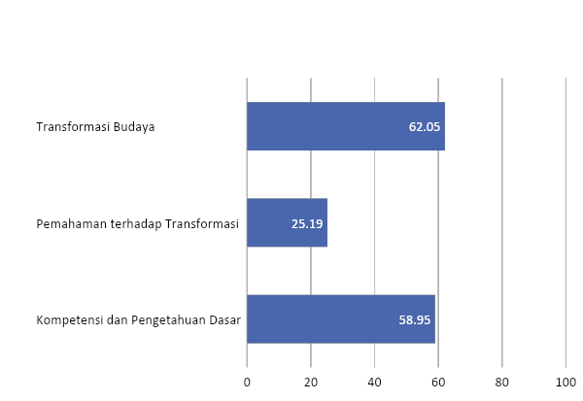

Figure 3 Natuna Regency Human Resources Domain Measurement Results

Competency and Basic Knowledge serve as the foundation that enables an individual or organization to understand and adapt to change. It encompasses the technical knowledge and skills required to perform specific tasks or jobs. Without strong competency and basic knowledge, it would be difficult to understand or implement change. Understanding of Transformation is the next step after building competency and basic knowledge. It involves understanding why change is necessary, its impact, and how to implement it. This understanding is crucial for accepting and committing to the transformation process.

Cultural Transformation is the end result of this process. It involves changes in values, attitudes, behaviors, and norms that support and facilitate transformation. Cultural transformation is often the most challenging part of this process, as it involves changing how people think and act. In this context, Competency and Basic Knowledge can be considered the most fundamental. Without this foundation, it would be difficult to understand or accept transformation, and nearly impossible to achieve cultural transformation. Therefore, building competency and basic knowledge is the first and most important step in the transformation process.

The human resources in various government departments or OPDs have relatively good competency and basic knowledge (score 58.95) but have weak understanding of transformation (score 25.19). With weak understanding of transformation, cultural transformation should be difficult to achieve, yet cultural transformation receives the highest score (62.05). There is a gap in understanding transformation where human resources have sufficient competency but are not optimal in understanding transformation, which can shape cultural transformation in the organizational environment. Understanding of transformation needs to be improved because some human resources are already capable of cultural transformation.

1. Process Domain

The measurement of process aspects in Natuna district aims to assess the level of readiness for digital transformation processes. There are four main indicators measured: vision and strategy, IT process maturity, digital automation conditions, and leadership, as shown in Figure 4. The indicator of vision and mission shows a readiness level of 24.55%. This value could indicate that the vision and strategy may not have been fully communicated or understood by the entire organization, or perhaps the existing strategy has not been fully aligned with the organization's business objectives. To improve this, OPDs need to ensure that the IT vision and strategy are clear and relevant to the business objectives, and effectively communicated throughout the organization.

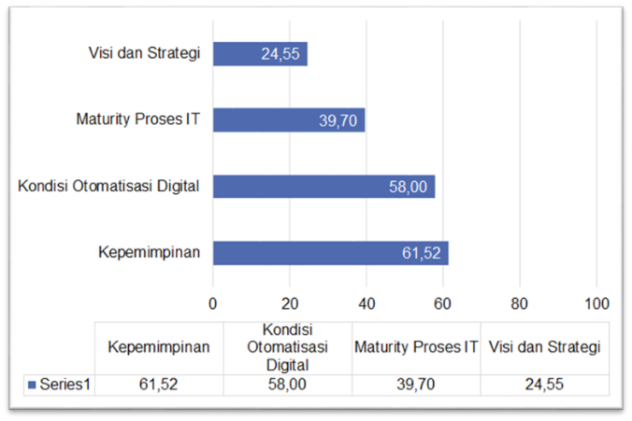

Figure 4 Natuna Regency Process Domain Digital Readiness Results

Meanwhile, the indicator for IT process maturity shows moderate results with a readiness level of 39.70%. However, there is still room for improvement to optimize and enhance IT processes by adopting governance standards such as the Information Technology Infrastructure Library (ITIL) or Control Objectives for Information and Related Technologies (COBIT). Furthermore, the indicator for digital automation conditions indicates a higher readiness level of 58%. This suggests that the organization has made good progress in its operations. However, there is still room for improvement and further expansion of this digital automation to enhance operational efficiency. Lastly, the leadership indicator shows the highest readiness level at 61.52%. This indicates that leadership has been able to build trust, encourage innovation, and drive the organization to innovate in response to rapid technological changes.

Overall, these results indicate that OPDs/organizations have made progress in the readiness of digital transformation processes, but there is still significant room for improvement in several areas. By focusing on improving vision and strategy, IT process maturity, digital automation, and leadership, organizations can enhance readiness for digital transformation.

1. Technology Domain

Assessing the technological aspect is crucial in gauging how prepared Kabupaten Natuna is for digital transformation. The indicators evaluated in this aspect include the readiness of the local government for adopting new technologies and the readiness of IT platforms. The assessment of the Technology domain in Kabupaten Natuna yields an average readiness score of 49.09, placing it in the Existence maturity level. The measurement results of the Technology Domain's readiness in Kabupaten Natuna can be seen in Figure 5.

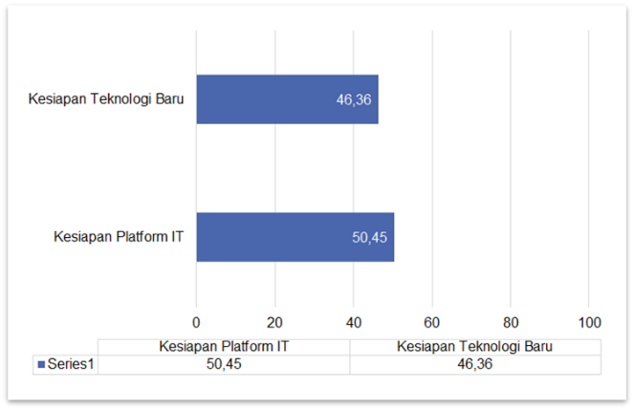

Figure 5 Natuna Regency Technology Domain Digital Readiness Results

From Figure 5 above, it is evident that a majority of respondents have shown readiness for new technologies at 46.36%, while the indicator for IT platform readiness stands at 50.45%. This indicates that respondents have moderate readiness for adopting new technologies. There is still ample room for improvement to enhance readiness for new technologies and IT platforms. Organizations can improve the quality of human resources, enhance infrastructure, and conduct research and development to keep up with evolving technological needs.

Regarding IT platform readiness, 36% of respondents disagree with adopting APIs in application development, while 27% agree and 9% strongly agree to adopt APIs. The same percentage distribution is observed regarding user interaction implementation in application development. Technology development with an API-based approach offers several advantages, including diversified technology, easy updates, and better scalability. Meanwhile, engaging user interaction through intuitive and responsive interface designs will help users adapt more quickly, reduce confusion, and minimize user errors. From the measurement results, there is still ample opportunity to provide understanding to respondents to enhance user interaction and adoption of API-based microservices methods according to existing needs.

1. Data Domain

The Data domain generally addresses data readiness, user data strategies, and future data management. The assessment of Data Management in Natuna District has an average digital transformation readiness score of 54.42, falling into the Existence maturity level. From the data management measurement results in Figure 6, it is found that respondents have fairly good data management policies (score 57.27), with governmental departments having formal Data Governance policies sanctioned by the respective departments as standards for Data Governance practices. Data management policies correlate with data management practices, scoring 51.82, which is not far from the data management policy score. Respondents also have an understanding of the importance of information security and its implementation (score 60.91), although it is still at a moderate level and needs improvement. Additionally, almost every respondent has a data management unit to carry out data management activities (score 64.55). Data analysis activities appear to still need improvement; internal data and social media data analysis received moderate scores.

Figure 6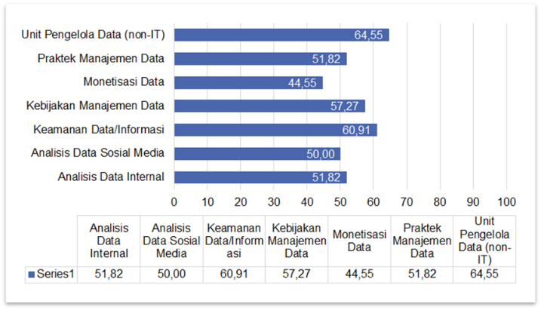 Natuna Regency Data Domain Readiness Results

This data analysis activity correlates with data monetization (score 44.55), suggesting that both internal and external data analysis, especially through social media, should be conducted more frequently to monetize data for decision-making purposes. In this aspect of data management, there is still plenty of room for improvement to organize data more effectively. Enhancements can be implemented from the infrastructure level to the human resources level to address various security threats in the field of data.

1. Digital Literacy Domain

The Digital Literacy domain, in general, encompasses aspects of human resources measured based on several main dimensions: information and literacy, communication skills, and knowledge related to data security. The assessment of Digital Literacy in Natuna Regency has an average readiness score for digital transformation of 75.39, as shown in Figure 7, which is the highest assessment among all domains of digital transformation readiness in Natuna Regency, falling into the Mature maturity level, indicating that digital literacy for digital transformation has been well managed, monitored, and evaluated. Measurement in the digital literacy domain involves four indicators: 1) communication and collaboration, 2) technology proficiency, 3) personal and device security, 4) information and data literacy. Overall, all respondents have good literacy skills, as indicated by scores greater than 70 for all indicators. In the communication and collaboration indicator (score 77.50), the majority of respondents understand the ethics when conducting digital activities on the internet, ranging from communication ethics, collaboration, to information dissemination. In terms of technology proficiency indicators, the majority of respondents also have basic technical skills in this digital era, such as: connecting devices to wifi, uploading and downloading files from the internet, and installing applications on devices.

Figure 7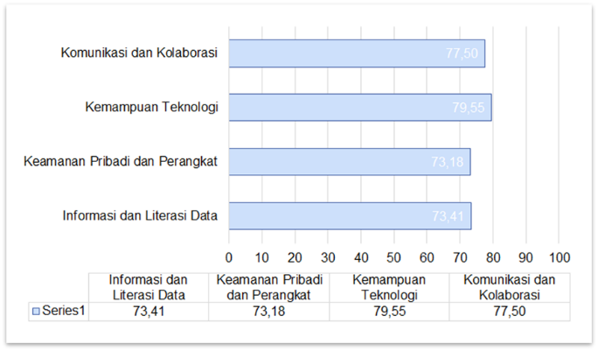 Natuna Regency Digital Literacy Domain Readiness Results

For the personal and device security indicator (score 73.18), the majority of respondents also understand the basic ways to secure personal data and devices, such as creating strong passwords, not uploading personal data on social media, backing up data on multiple devices, etc. And for the information and data literacy indicator (score 73.41), the majority of respondents are knowledgeable about how to search for information or data, compare information, seek the truth of information, and store it. Over time, literacy activities must be continually conducted and updated to enhance understanding of digital activities, especially in the context of digital transformation.

Based on the results of the digital readiness assessment, SWOT analysis will be conducted for each domain as the basis for developing future improvement strategies. Strengths are positive internal factors that provide a competitive advantage. Examples may include technological superiority, strong brand, quality human resources, or efficient production processes. Weaknesses are internal factors that are detrimental or limit the organization's capabilities. Weaknesses may include lack of resources, weak management, technological limitations, or dependence on a single product or market. Opportunities are favorable external factors that can be exploited by the organization. Opportunities may include changes in market trends, new technological developments, industry deregulation, or new market growth. Threats are external factors that have the potential to harm or hinder the organization's success. Threats may include intense competition, regulatory changes, government policy changes, or economic risks.

Certainly, here's a SWOT analysis for each domain of digital readiness measurement in the Natuna regency.

1. Human Resources Domain

* **Strengths**

High Digital Literacy, Natuna Regency boasts a high level of digital literacy at 75.39%, indicating a strong understanding of digital technology. Good Governance, The Natuna Regency Government exhibits good governance in data management, supporting governmental business processes. Human Resource Competence, Adequate competence among human resources within the Natuna Regency Government indicates potential for effective implementation of digital transformation.

* **Weaknesses**

Low Technological Readiness, The technology domain exhibits a low score in digital transformation readiness in Natuna Regency, indicating weaknesses in infrastructure and technology adoption that need enhancement. Low Process Readiness, Readiness in terms of business processes is also low, suggesting weaknesses in management processes that need to be addressed to support digital transformation. Low Data Management Readiness, Despite the presence of good governance, the readiness score for data management remains relatively low, indicating the need to improve efficiency in data management.

* **Opportunities**

Technology Development Potential, The awareness of the low technological readiness presents an opportunity to develop better infrastructure and technology adoption in Natuna Regency. Opportunities for Process Enhancement, The low readiness in processes also provides opportunities for improving the efficiency of governmental business processes. Support from High Digital Literacy, The high level of digital literacy in Natuna Regency can serve as a strong foundation for implementing changes and innovations in governmental processes.

* **Threats**

Challenges in Technology Enhancement, Challenges in improving technological readiness such as budget limitations and existing infrastructure constraints can pose threats to digital transformation. Slow Response to Change, Low readiness in processes and data management can result in slow responses to environmental changes and societal demands for government services. Potential Human Resource Limitations, Despite existing competencies, potential limitations in human resources for the development and implementation of digital transformation can be a threat that needs to be addressed. This SWOT analysis can serve as a basis for designing a more effective digital transformation strategy in Natuna Regency by leveraging strengths and opportunities while addressing weaknesses and confronting potential threats.

1. Process Domain

* **Strengths**

Strong Leadership, The high level of readiness in leadership aspects indicates the presence of strong and effective leadership in guiding the organization towards digital transformation. Progress in Digital Automation: The relatively high level of readiness in digital automation conditions indicates that the organization has made progress in adopting technology to enhance operational efficiency.

* **Weaknesses**

Low Readiness Level in Vision and Strategy, The low readiness level in the vision and strategy indicator indicates weaknesses in communication or understanding regarding IT vision and strategy across the organization. Moderate IT Process Maturity, Despite progress in IT process maturity, there are still weaknesses that require improvement to further optimize IT processes.

* **Opportunities**

Opportunities to Enhance Vision and Strategy, The organization has opportunities to enhance its IT vision and strategy by ensuring that they are clear, relevant to business objectives, and effectively communicated throughout the organization. Potential for Digital Automation Expansion, Despite progress in digital automation, there are still opportunities for further expansion in adopting technology to enhance operational efficiency.

* **Threats**

Threat of Rapid Technological Change: Rapid technological advancements pose a threat to organizations that are not fully prepared in terms of vision, strategy, and IT processes, as it can leave them lagging behind or unable to quickly adapt to new challenges. Threat of Intense Competition: In a competitive environment, weaknesses in vision, strategy, and IT processes can increase the risk of intense competition, where digitally-ready organizations have a greater competitive advantage. By leveraging existing strengths, addressing weaknesses, seizing opportunities, and confronting emerging threats, organizations can design more effective strategies to enhance readiness for digital transformation. This can be achieved through improving communication of vision and strategy, enhancing IT process maturity, expanding digital automation, and strengthening leadership to tackle present and future challenges in the digital era.

1. Technology Domain

* **Strengths**

Moderate Readiness for New Technology, Natuna Regency exhibits moderate readiness for adopting new technology, as indicated by a readiness indicator for new technology at 46.36%. This suggests that the organization has a sufficient foundation to adopt new technology in the digital transformation process. Moderate Readiness of IT Platforms: Natuna Regency's readiness of IT platforms reaches 50.45%, indicating that the organization has a moderate foundation to adopt the necessary IT platforms to support digital transformation.

* **Weaknesses**

Lack of Support for API Adoption in Application Development: Only a small portion of respondents agree to adopt APIs in application development, indicating a lack of understanding or awareness of the benefits and necessity of API adoption in application development. Insufficient Understanding of Effective User Interaction: Insufficient understanding and support for effective user interaction in application development, such as intuitive and responsive interface design, can be a constraint in creating a satisfying user experience.

* **Opportunities**

Improving Understanding of New Technology Adoption: There is an opportunity to enhance respondents' understanding and awareness of the benefits of adopting new technology, such as the use of APIs in application development, through appropriate training and awareness programs. Enhancing User Interaction, Opportunities to improve user interaction in application development, such as through intuitive and responsive interface design, can create a better user experience and increase application adoption by users.

* **Threats**

Challenges in Adopting New Technology, Challenges that may arise in adopting new technology, such as lack of support or understanding, can hinder progress in digital transformation and increase the risk of technological lag. Threats of Infrastructure and Human Resource Limitations: Infrastructure limitations and a lack of quality human resources can be barriers to adopting new technology and enhancing effective user interaction. By leveraging existing strengths, addressing weaknesses, seizing opportunities, and confronting emerging threats, organizations can design more effective strategies to enhance readiness in technology aspects and digital transformation overall. This can be achieved through improving understanding and support for the adoption of new technology, as well as enhancing user interaction in application development.

1. Data Domain

* **Strengths**

Formal Data Management Policy: Natuna Regency has a fairly good data management policy, with a score of 57.27, indicating the presence of a formal framework for data management. This can provide a strong foundation for effective data management. Understanding the Importance of Information Security: Respondents have a good understanding of the importance of information security and its implementation, albeit at a moderate level (score of 60.91). This indicates a good awareness of the need to protect data.

* **Weaknesses**

Data Analysis Activities to be Enhanced: Although there are existing data analysis activities, there is still room for improvement, especially in internal data analysis and social media data analysis, which received moderate scores. This indicates weaknesses in data analysis capacity that need to be addressed. Low Data Monetization: A data monetization score of only 44.55 indicates that there are still weaknesses in leveraging data for decision-making and potential revenue generation.

* **Opportunities**

Improving Data Analysis: There are opportunities to enhance data analysis activities, especially in internal and external data analysis through social media, enabling data monetization for better decision-making. Enhancing Data Governance: Organizations can leverage existing data management policies as a foundation to improve overall data governance, including infrastructure and human resources, to address existing data security threats.

* **Threats**

Data Security Threats: The availability of large amounts of data and the increasing threats to data security indicate that organizations need to enhance efforts to protect data from attacks and security breaches. Infrastructure and Human Resource Limitations: Infrastructure and human resource constraints can be barriers to improving data governance and the data analysis capacity required for better digital transformation.

1. Literasi Digital Domain

* **Strengths**

High Digital Literacy Capability: Natuna Regency exhibits strength in high digital literacy capability, as demonstrated by the average digital transformation readiness score of 75.39, which falls within the Mature maturity level. This indicates that the human resources in Natuna Regency possess good digital literacy skills to support digital transformation. Good Understanding of Ethics and Digital Security: The majority of respondents have a good understanding of ethics and digital security, such as communication ethics, safe password usage, and personal data security measures. This indicates that awareness of the importance of digital security has been well instilled in Natuna Regency.

* **Weaknesses**

Limitations of Digital Literacy Updates: Despite the high level of digital literacy capability, regular updates to digital literacy need to be considered. As technology continues to evolve, digital literacy activities must be consistently refreshed to remain relevant to technological advancements. Potential for Digital Literacy Imbalance: Although the majority of respondents have good digital literacy skills, there is potential for an imbalance in digital literacy among individuals or groups that can affect the overall level of digital transformation readiness.

* **Opportunities**

Improving Digital Literacy Skills: There are opportunities to continuously enhance digital literacy skills through training and education programs, as well as updating digital literacy content in line with technological advancements. Utilizing Digital Literacy for Further Transformation: With high digital literacy capabilities, there are opportunities to use digital literacy as a foundation for further transformation in various aspects of life and public services in Natuna Regency.

* **Threats**

Threat of Rapid Technological Change: Rapid technological changes can pose a threat to existing levels of digital literacy, as there is a possibility of a gap between digital literacy skills and emerging technologies. Continuously Evolving Data Security Threats: Continuously evolving data security threats can also pose a threat to digital literacy levels, as deeper understanding and higher skills are required to address new and complex digital security threats.

IV. CONCLUSION

Based on the SWOT analysis, three conclusions can be drawn based on TOWS analysis for Natuna Regency to optimize digital literacy and confront digital transformation. Firstly, Natuna Regency can leverage its internal strengths, such as high digital literacy, good governance, and strong leadership, to seize opportunities like enhancing data analytics and fostering collaboration with the private sector and educational institutions. The SO strategy is pertinent in this context, where harnessing internal strengths can maximize digital growth potential.

Secondly, it's crucial for Natuna Regency to address its internal weaknesses, such as moderate readiness for new technologies, by capitalizing on opportunities like enhancing digital literacy and skills. The WO strategy is pivotal here, where improving digital literacy can pave the way for adopting new technologies and fortifying Natuna's position in the digital transformation era.

Thirdly, Natuna should capitalize on its internal strengths, such as readiness in data security, to counter threats such as weaknesses in infrastructure and human resources. The ST strategy can provide guidance in bolstering cyber defenses and ensuring Natuna effectively tackles data security challenges while remaining focused on enhancing digital literacy to adapt to technological changes. By implementing these strategies, Natuna can enhance its technological readiness and capitalize on opportunities in the digital era more effectively.

REFERENCES

Anthony, B. (2023). The Role of Community Engagement in Urban Innovation Towards the Co-Creation of Smart Sustainable Cities. *Journal of the Knowledge Economy*. https://doi.org/10.1007/s13132-023-01176-1

Ben Ghrbeia, S., & Alzubi, A. (2024). Building Micro-Foundations for Digital Transformation: A Moderated Mediation Model of the Interplay between Digital Literacy and Digital Transformation. *Sustainability*, *16*(9), 3749. https://doi.org/10.3390/su16093749

Karmaker, A. K., Islam, S. M. R., Kamruzzaman, M., Rashid, M. M. U., Faruque, M. O., & Hossain, M. A. (2023). Smart City Transformation: An Analysis of Dhaka and Its Challenges and Opportunities. In *Smart Cities* (Vol. 6, Issue 2, pp. 1087–1108). MDPI. https://doi.org/10.3390/smartcities6020052

Latupeirissa, J. J. P., Dewi, N. L. Y., Prayana, I. K. R., Srikandi, M. B., Ramadiansyah, S. A., & Pramana, I. B. G. A. Y. (2024). Transforming Public Service Delivery: A Comprehensive Review of Digitization Initiatives. In *Sustainability (Switzerland)* (Vol. 16, Issue 7). Multidisciplinary Digital Publishing Institute (MDPI). https://doi.org/10.3390/su16072818

Philipp, R. (2020). Digital readiness index assessment towards smart port development. *Sustainability Management Forum | NachhaltigkeitsManagementForum*, *28*(1–2), 49–60. https://doi.org/10.1007/s00550-020-00501-5

Pirola, F., Cimini, C., & Pinto, R. (2020). Digital readiness assessment of Italian SMEs: a case-study research. *Journal of Manufacturing Technology Management*, *31*(5), 1045–1083. https://doi.org/10.1108/JMTM-09-2018-0305

Puspita, I. (2024). Impact of Digital Literacy Programs on Information Access in Rural African Communities in Indonesia. *African Journal of Information and Knowledge Management*, *2*(1), 13–26. https://doi.org/10.47604/ajikm.2266

Ramdhan, D. (2023). Digital Transformation In Public Services: Opportunities and Challenges. *International Journal of Education, Information Technology and Others (IJEIT)*, *6 (2)*, 274–280.

Wang, C., & Si, L. (2024). The Intersection of Public Policy and Public Access: Digital Inclusion, Digital Literacy Education, and Libraries. *Sustainability (Switzerland)* , *16*(5). https://doi.org/10.3390/su16051878